1. **What is Loose Coupling?**

Loose coupling is a design goal that seeks to reduce the inter-dependencies between components of a system with the goal of reducing the risk that changes in one component will require changes in any other component. Loose coupling is much more generic concept intended to increase the flexibility of system, make it more maintainable and makes the entire framework more stable.

1. **What is a Dependency?**

Whenever a class A uses another class or interface B, then A depends on B. A cannot carry out it's work without B, and A cannot be reused without also reusing B. In such a situation the class A is called the "dependant" and the class or interface B is called the "dependency". A dependent depends on its dependencies.

1. **What is IOC (Inversion of Control)?**

Inversion of Control is a principle in software engineering by which the control of objects or portions of a program is transferred to a container or framework. It’s most often used in the context of object-oriented programming. IoC enables a framework to take control of the flow of a program and make calls to our custom code. Inversion of Control can be achieved through various mechanisms such as: Strategy design pattern, Service Locator pattern, Factory pattern, and Dependency Injection (DI).

1. **What is Dependency Injection?**

Dependency injection is a pattern through which to implement IoC, where the control being inverted is the setting of object’s dependencies.

1. **Types of Dependency injection?**

Spring supports 2 types of dependency injection, they are:

1) Constructor-based dependency injection: It is accomplished when the container invokes a class constructor with a number of arguments, each representing a dependency on other class.

2) Setter-based dependency injection: It is accomplished by the container calling setter methods on your beans after invoking a no-argument constructor or no-argument static factory method to instantiate your bean.

1. **Can you give few examples of Dependency Injection?**

<https://www.journaldev.com/2394/java-dependency-injection-design-pattern-example-tutorial>

1. **What is Auto Wiring?**

Autowiring feature of spring framework enables you to inject the object dependency implicitly. It internally uses setter or constructor injection. Autowiring can't be used to inject primitive and string values. It works with reference only.

<http://www.mkyong.com/spring/spring-auto-wiring-beans-in-xml/>

<https://www.youtube.com/watch?v=K43qyHJXmWI>

<https://www.youtube.com/watch?v=xTGkWSZkyNg&t=144s>

1. **What are the important roles of an IOC Container?**

* Instantiating the bean
* Wiring the beans together
* Configuring the beans
* Managing the bean’s entire life-cycle

<https://www.quora.com/Why-is-a-spring-container-known-as-an-IOC-container>

1. **What are Bean Factory and Application Context?**

There are two types of IoC containers:

* BeanFactory
* ApplicationContext

1. **Can you compare Bean Factory with Application Context?**

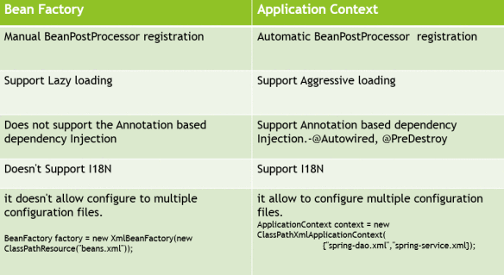

<https://www.oodlestechnologies.com/blogs/Difference-between-BeanFactory-and-ApplicationContext>

<https://www.digizol.com/2008/09/lazy-load-pre-load-beans-spring.html>

1. How do you create an application context with Spring?
2. **How does Spring know where to search for Components or Beans?**

Spring is a dependency injection framework. It is all about beans and wiring in dependencies.

The first step of defining Spring Beans is by adding the right annotation — @Component or @Service or @Repository.

However, Spring does not know about the bean unless it knows where to search for it.

This part of “telling Spring where to search” is called a Component Scan.

You define the packages that have to be scanned.

Once you define a Component Scan for a package, Spring would search the package and all its sub packages for components/beans.

1. **What is a Component Scan?**

The @ComponentScan annotation is used with the @Configuration annotation to tell Spring the packages to scan for annotated components. @ComponentScan also used to specify base packages and base package classes using thebasePackageClasses or basePackages attributes of @ComponentScan.

The basePackageClasses attribute is a type-safe alternative to basePackages. When you specify basePackageClasses, Spring will scan the package (and subpackages) of the classes you specify.

1. How do you define a component scan in XML and Java Configurations?
2. How is it done with Spring Boot?
3. **What does @Component signify?**

The @Component annotation marks a java class as a bean so the component-scanning mechanism of spring can pick it up and pull it into the application context.

<https://howtodoinjava.com/spring-core/how-to-use-spring-component-repository-service-and-controller-annotations/>

1. What does @Autowired signify?

We can use Spring @Autowired annotation for spring bean autowiring. @Autowired annotation can be applied on variables and methods for autowiring byType. We can also use @Autowired annotation on constructor for constructor based spring autowiring.

For @Autowired annotation to work, we also need to enable annotation based configuration in spring bean configuration file. This can be done by context:annotation-config element or by defining a bean of type

org.springframework.beans.factory.annotation.AutowiredAnnotationBeanPostProcessor

<https://www.journaldev.com/2623/spring-autowired-annotation>

1. **What’s the difference Between @Controller, @Component, @Repository, and @Service Annotations in Spring?**

@Component – generic and can be used across application.

@Service – annotate classes at service layer level.

@Controller – annotate classes at presentation layers level, mainly used in Spring MVC.

@Repository – annotate classes at persistence layer, which will act as database repository.

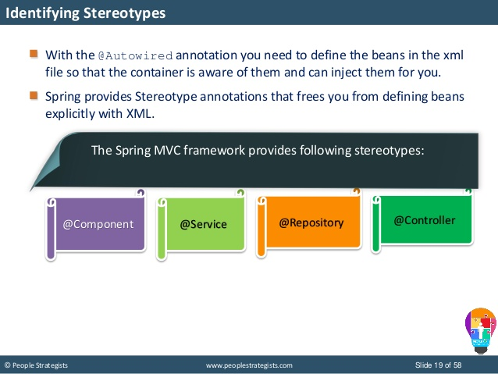

1. **What is the default scope of a bean?**

Singleton bean scope is default scope for bean declared in Spring and applicable when you don't specify scope attribute while specifying bean details in ApplicationContext.xml or Spring configuration file. Singleton bean scope is like Singleton pattern in Java where only one instance of bean is created per Spring container. So no matter how many times you call getBean() method, same bean instance will be returned if its bean scope is declared as Singleton.

<http://www.baeldung.com/spring-bean-scopes>

<https://javarevisited.blogspot.com/2012/05/what-is-bean-scope-in-spring-mvc.html>

1. **Are Spring beans thread safe?**

Thread safety is a different context . Singleton spring beans has no relation with thread safety. spring container only manages life-cycle of objects and guaranteed that only one object in spring container. so If an Non thread safe object is injected then obviously it is not thread safe. To make it thread safe you have to handle it by coding.

If it is a web-application , Scope("request") can achieve thread-safety as for each new request it creates a new object or scope("prototype") will do this.(for each invocation it creates new bean .)

<http://javaonfly.blogspot.com/2016/03/is-spring-bean-thread-safe.html>

1. **What are the other scopes available?**

[**https://www.youtube.com/watch?v=NnNvDknQJt0&t=576s**](https://www.youtube.com/watch?v=NnNvDknQJt0&t=576s)

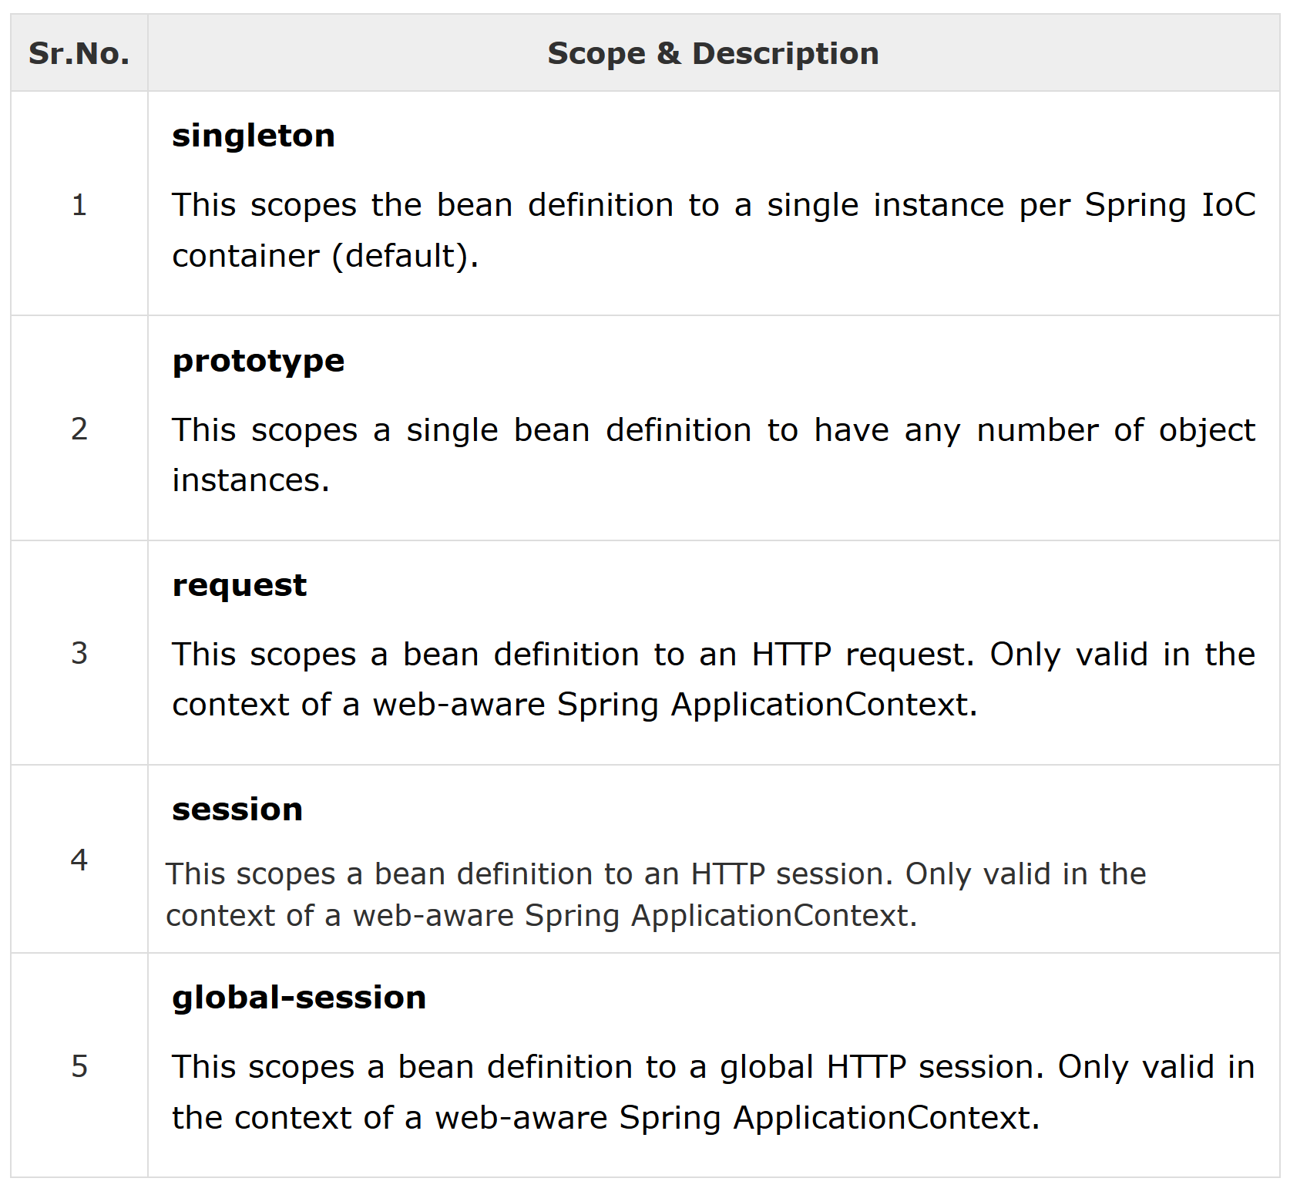

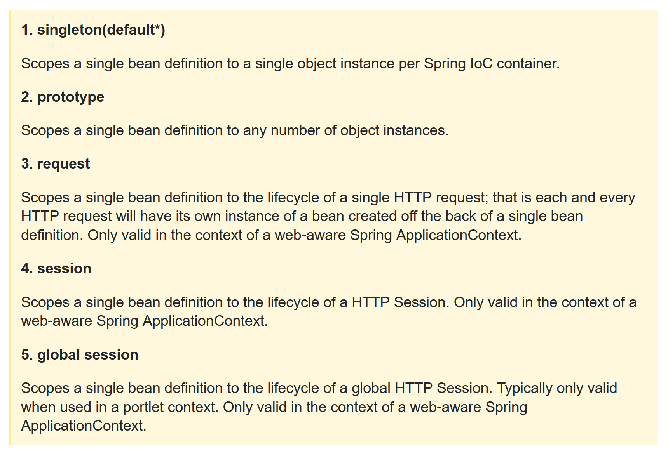

1. **How is Spring’s singleton bean different from Gang of Four Singleton Pattern?**

The Gang of Four defines Singleton as having only one instance per ClassLoader whereas Spring singleton is defined as one instance of bean definition per container.

<https://www.javadevjournal.com/spring/spring-singleton-vs-singleton-pattern/>

1. **What are the different types of dependency injections?**

Spring supports 2 types of dependency injection, they are:

1) Constructor-based dependency injection: It is accomplished when the container invokes a class constructor with a number of arguments, each representing a dependency on other class.

2) Setter-based dependency injection: It is accomplished by the container calling setter methods on your beans after invoking a no-argument constructor or no-argument static factory method to instantiate your bean.

1. **What is setter injection?**

Setter-based DI is accomplished by the container calling setter methods on your beans after invoking a no-argument constructor or no-argument static factory method to instantiate your bean.

<https://www.tutorialspoint.com/spring/setter_based_dependency_injection.htm>

1. **What is constructor injection?**

Constructor-based DI is accomplished when the container invokes a class constructor with a number of arguments, each representing a dependency on the other class.

<https://www.tutorialspoint.com/spring/constructor_based_dependency_injection.htm>

1. **How do you choose between setter and constructor injections?**

<https://javarevisited.blogspot.com/2012/11/difference-between-setter-injection-vs-constructor-injection-spring-framework.html>

1. **What are the different options available to create Application Contexts for Spring?**

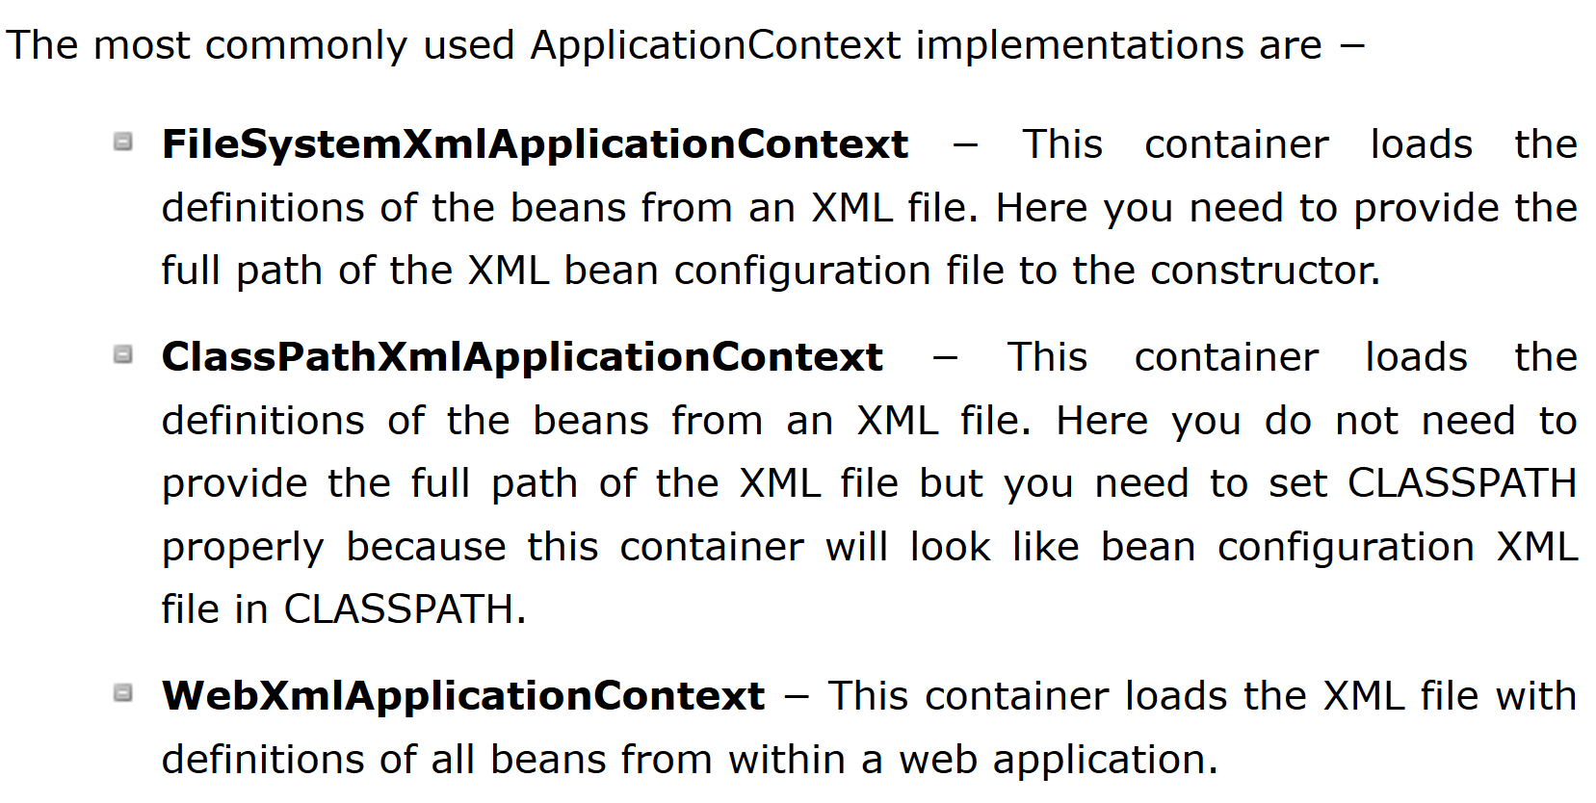

<https://www.tutorialspoint.com/spring/spring_applicationcontext_container.htm>

1. What is the difference between XML and Java Configurations for Spring?
2. How do you choose between XML and Java Configurations for Spring?

Use Annotations in anything that is stable and defines the core structure of the application. Anything that would need a code change is okay to sit as an annotation.

Use XML based configurations when you know you may have a need to alter the behavior of an application without the need of compiling and deploying the code all over again.

<https://dzone.com/articles/spring-framework-xml-vs-annotations>

1. How does Spring do Autowiring?

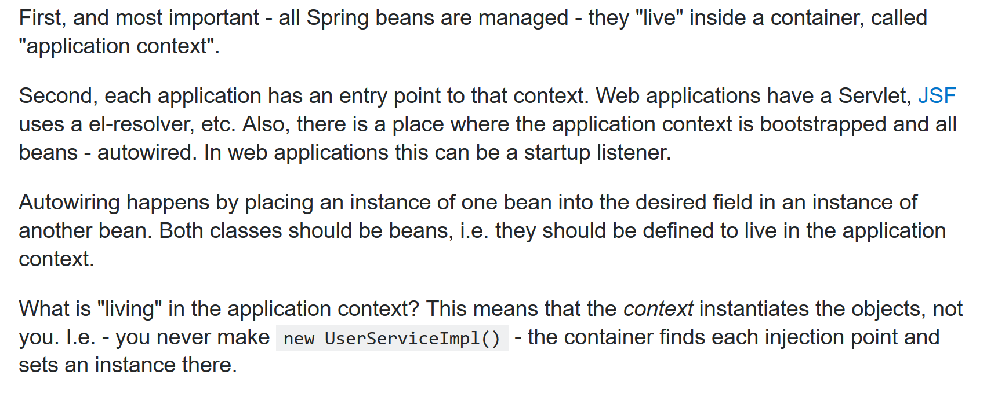

<https://stackoverflow.com/questions/3153546/how-does-autowiring-work-in-spring>

1. What are the different kinds of matching used by Spring for Autowiring?
2. How do you debug problems with Spring Framework?
3. How do you solve NoUniqueBeanDefinitionException?

<https://springframework.guru/fixing-nonuniquebeandefinitionexception-exceptions/>

1. How do you solve NoSuchBeanDefinitionException?

<https://stackoverflow.com/questions/39173982/what-is-a-nosuchbeandefinitionexception-and-how-do-i-fix-it>

1. What is @Primary?

<https://www.youtube.com/watch?v=GwXSYVJYNDM>

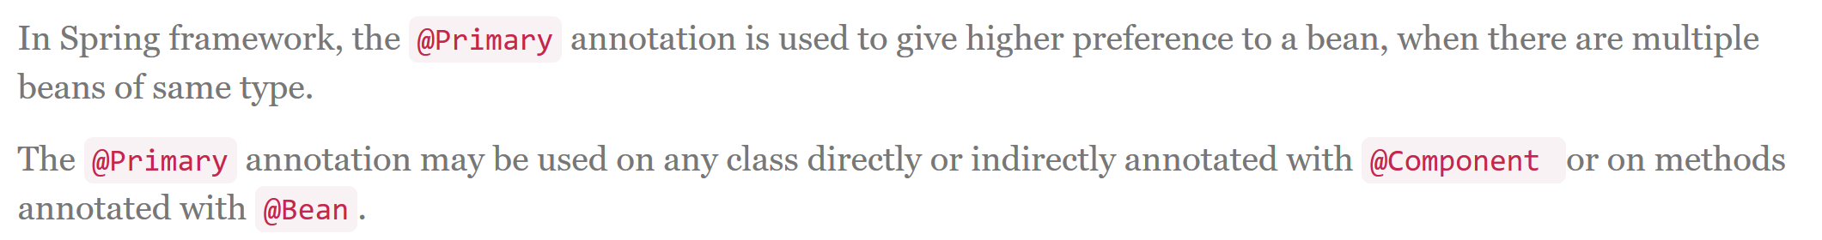

<https://www.boraji.com/spring-primary-annotation-example>

1. What is @Qualifier?

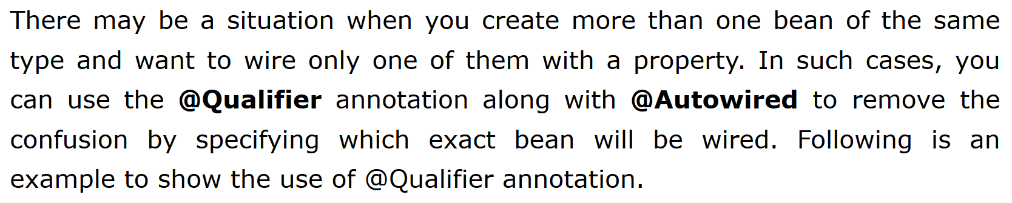

<https://www.tutorialspoint.com/spring/spring_qualifier_annotation.htm>

1. What is CDI (Contexts and Dependency Injection)?

<https://www.youtube.com/watch?v=8HKZ7S8FWzs>

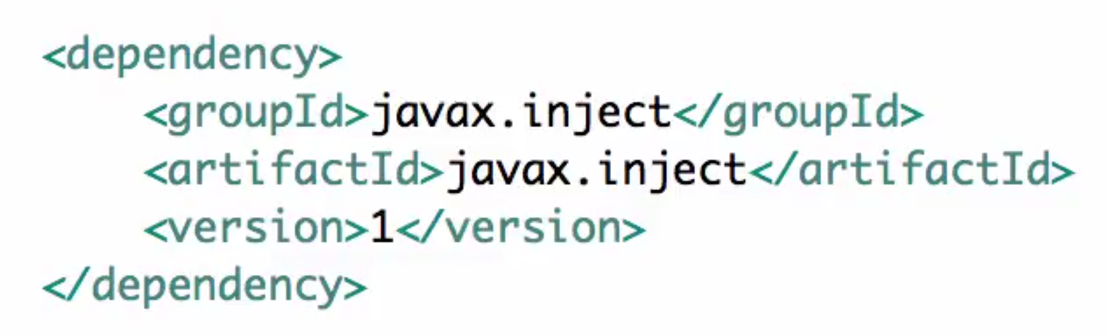

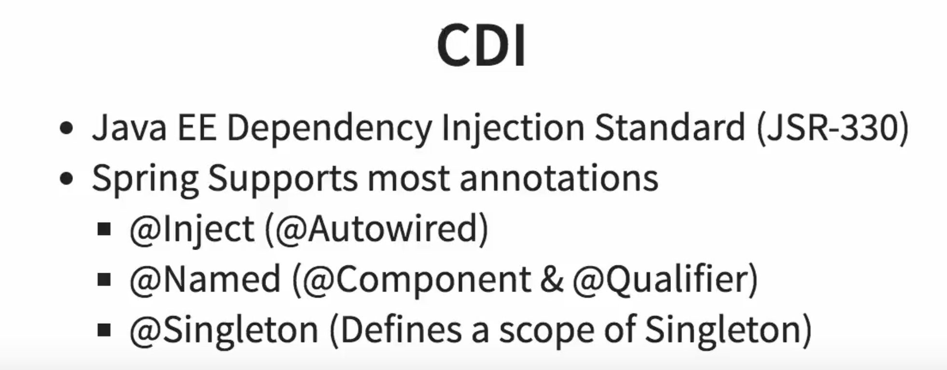

1. Does Spring Support CDI?

Yes

1. Would you recommed to use CDI or Spring Annotations?
2. What are the major features in different versions of Spring?
3. What are new features in Spring Framework 4.0?

<https://www.linkedin.com/pulse/what-difference-between-spring-3-4-pankaj-kumar/>

1. What are new features in Spring Framework 5.0?

<https://dzone.com/articles/whats-new-in-spring-framework-5>

1. What are important Spring Modules?

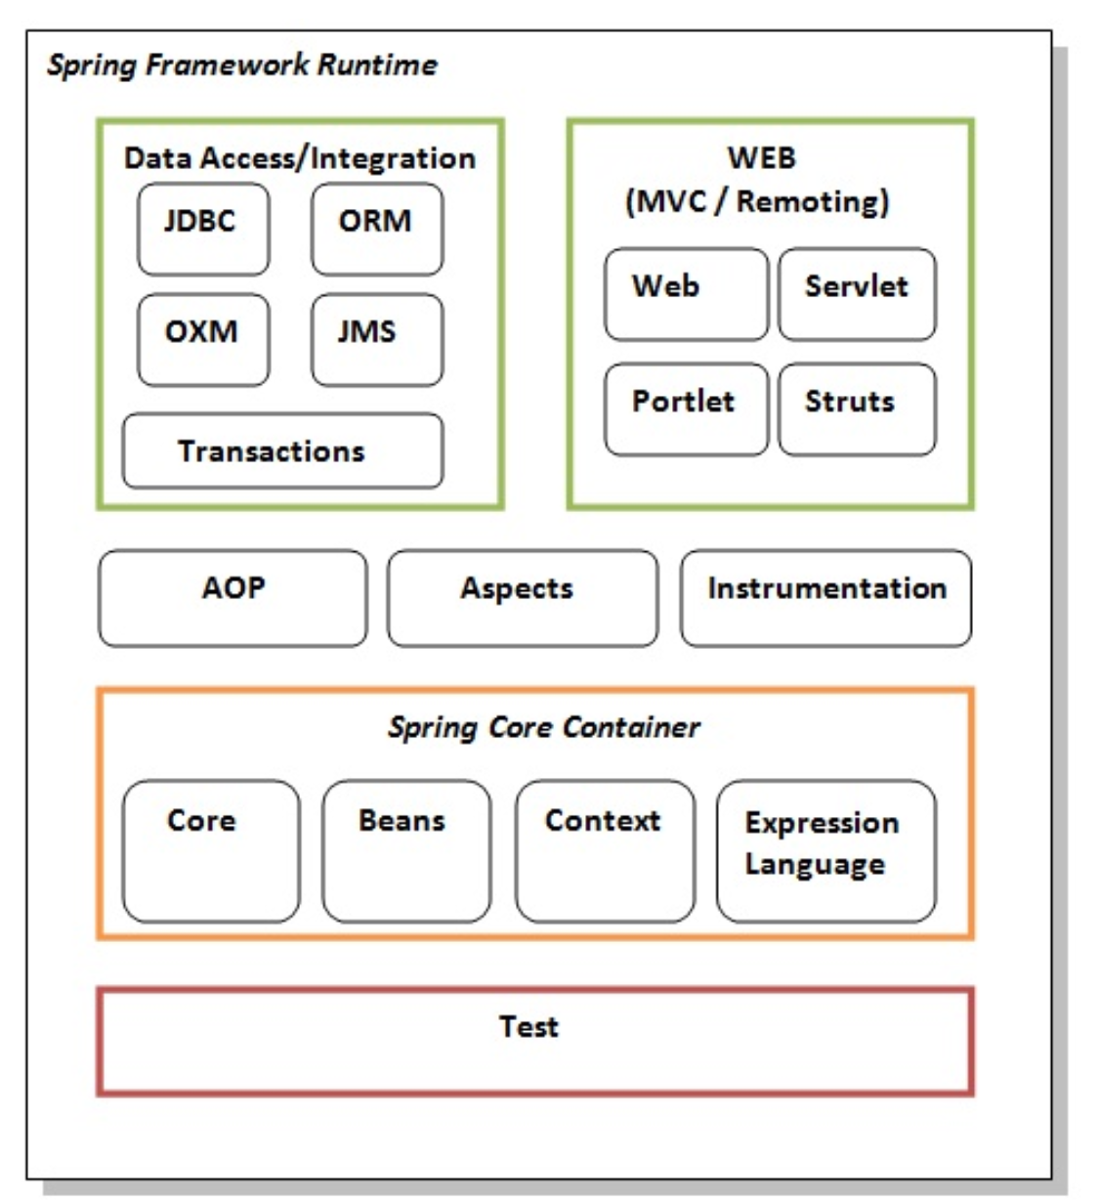

<https://www.javatpoint.com/spring-modules>

1. What are important Spring Projects?

<https://spring.io/projects>

1. What is the simplest way of ensuring that we are using single version of all Spring related dependencies?

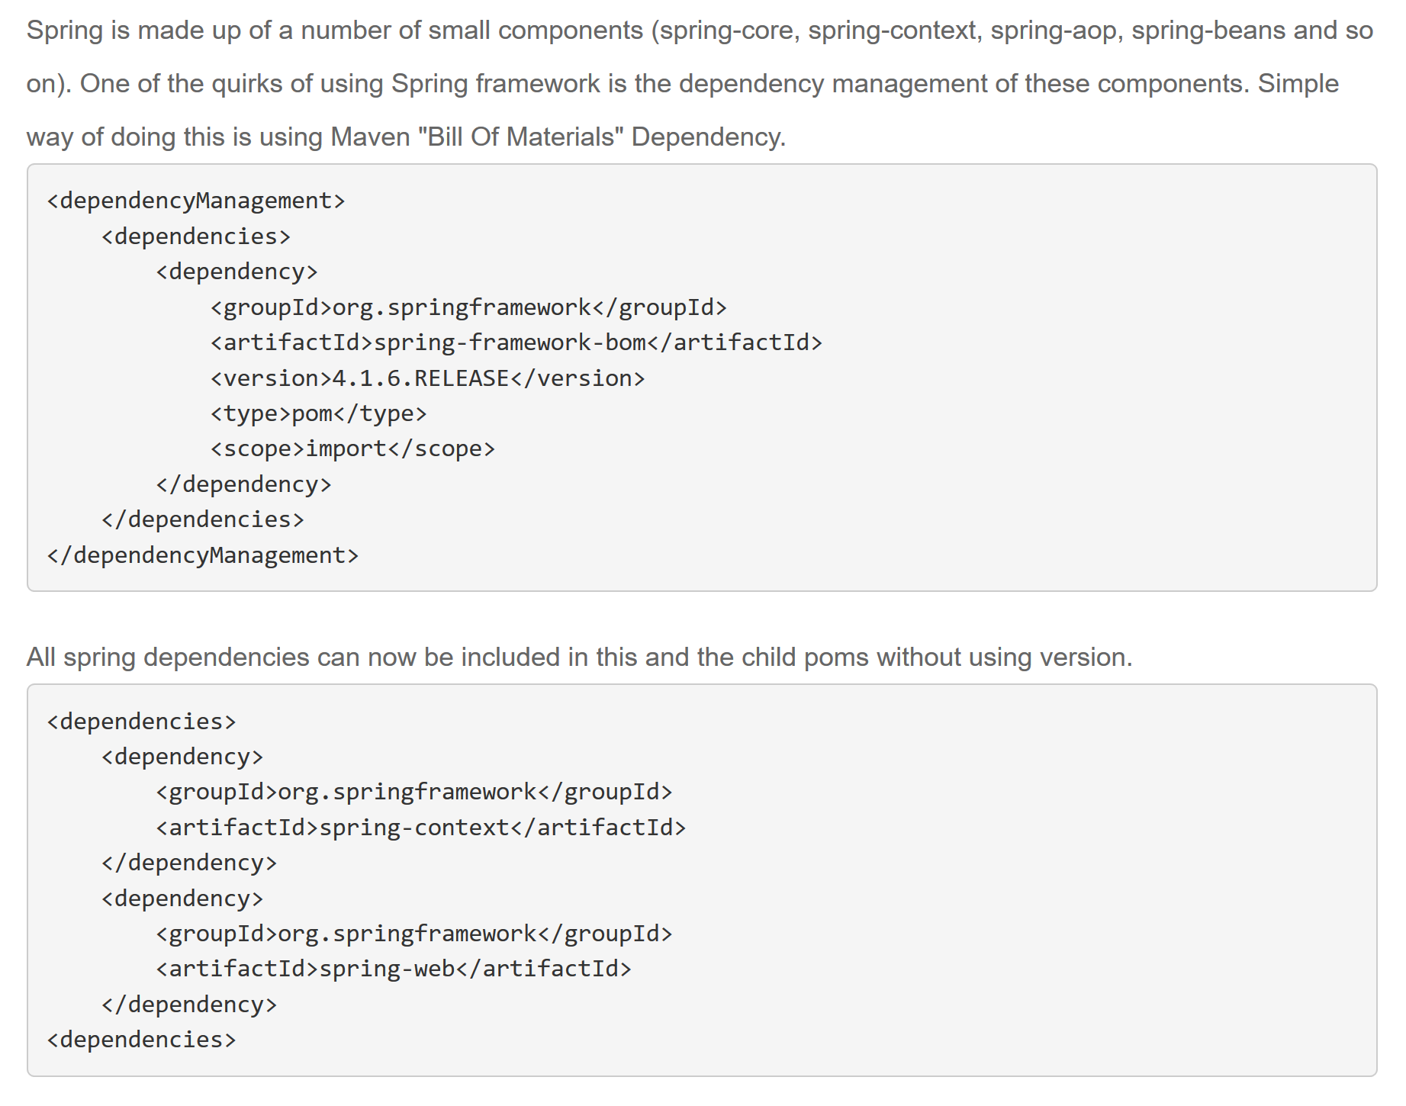

1. **Name some of the design patterns used in Spring Framework?**

<https://premaseem.wordpress.com/2013/02/09/spring-design-patterns-used-in-java-spring-framework/>

1. **What do you think about Spring Framework?**

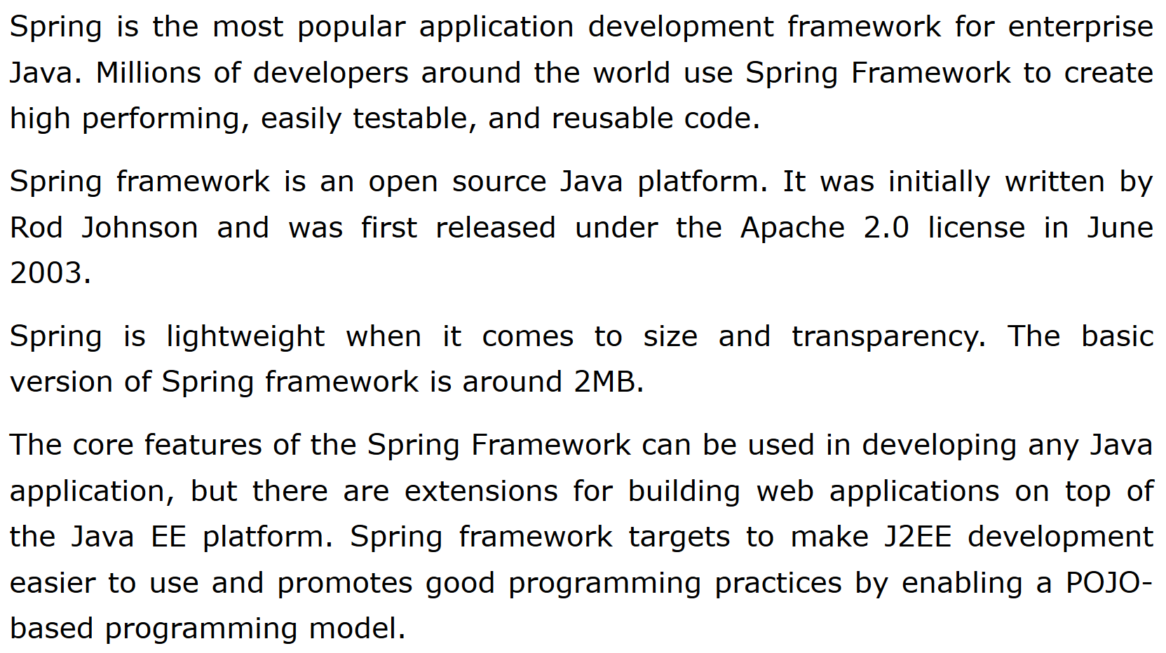

1. **Why is Spring Popular?**

<https://www.freelancinggig.com/blog/2018/04/26/spring-popular-java-frameworks/>

1. Can you give a big picture of the Spring Framework?
2. **Spring MVC**

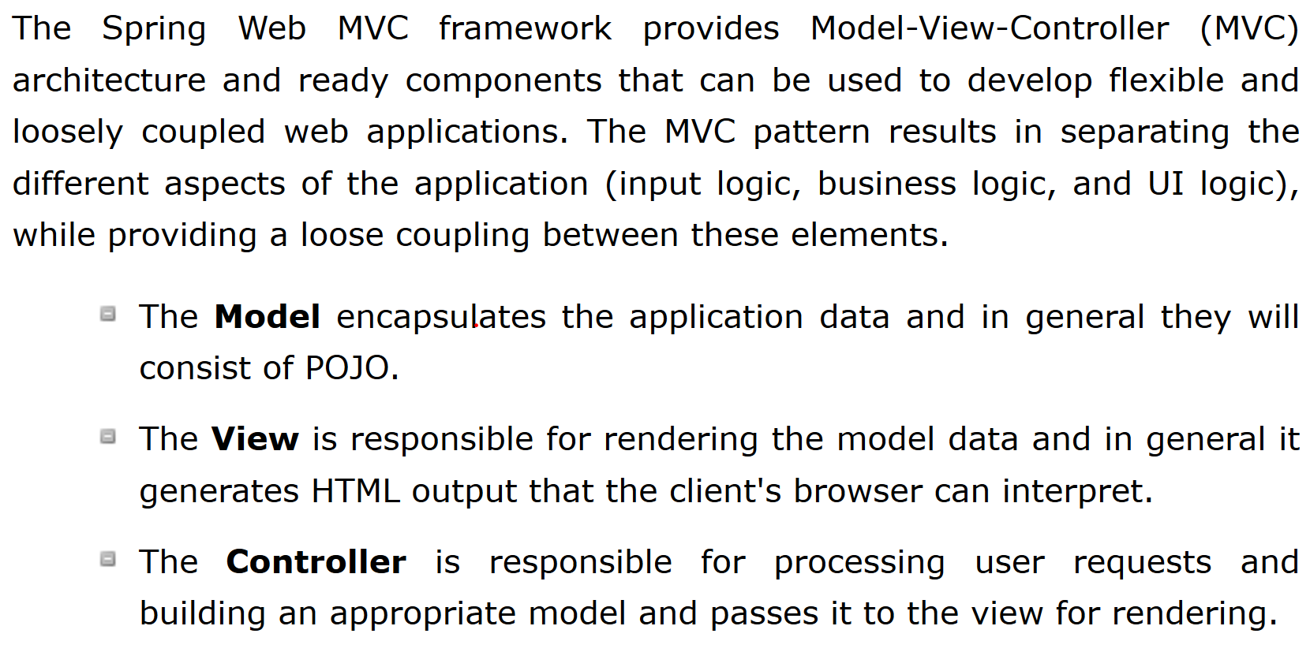

<https://www.tutorialspoint.com/spring/spring_web_mvc_framework.htm>

1. **What is Model 1 architecture?**

<https://www.javatpoint.com/model-1-and-model-2-mvc-architecture>

1. **What is Model 2 architecture?**

<https://www.javatpoint.com/model-1-and-model-2-mvc-architecture>

1. **What is Model 2 Front Controller architecture?**

<https://www.tutorialspoint.com/design_pattern/front_controller_pattern.htm>

1. Can you show an example controller method in Spring MVC?
2. Can you explain a simple flow in Spring MVC?
3. **What is a ViewResolver?**

ViewResolver is an interface to be implemented by objects that can resolve views by name. There are plenty of ways using which you can resolve view names. These ways are supported by various in-built implementations of this interface. Most commonly used implementation is InternalResourceViewResolver class.

<https://www.quora.com/What-does-the-ViewResolver-class>

1. **What is Model?**

The Model encapsulates the application data and in general they will consist of POJO.

1. **What is ModelAndView?**

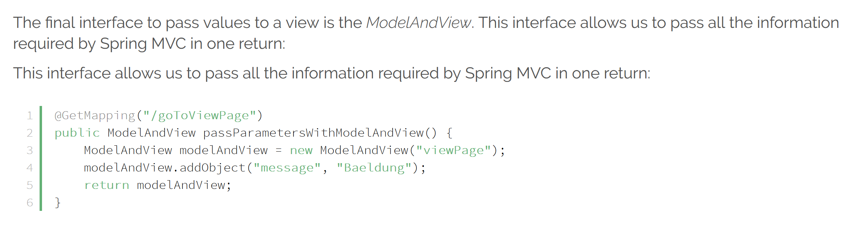

<http://www.baeldung.com/spring-mvc-model-model-map-model-view>

1. What is a RequestMapping?

<http://www.baeldung.com/spring-requestmapping>

<https://springframework.guru/spring-requestmapping-annotation/>

1. What is Dispatcher Servlet?

<https://www.tutorialspoint.com/spring/spring_web_mvc_framework.htm>

1. How do you set up Dispatcher Servlet?

<https://howtodoinjava.com/spring5/webmvc/spring-dispatcherservlet-tutorial/>

1. What is a form backing object?

Form Backing Object/Command Object. This is a POJO that is used to collect all information on a form. ... It is also called a Command Object in some Spring tutorials. For example, an add a new car form page will have a Car form backing object with attribute data such as Year, Make and Model.

<https://stackoverflow.com/questions/3588971/how-does-formbackingobject-and-referencedata-object-operate-in-spring-web-mvc-cy>

1. How is validation done using Spring MVC?

<https://www.journaldev.com/2668/spring-validation-example-mvc-validator>

1. What is BindingResult?

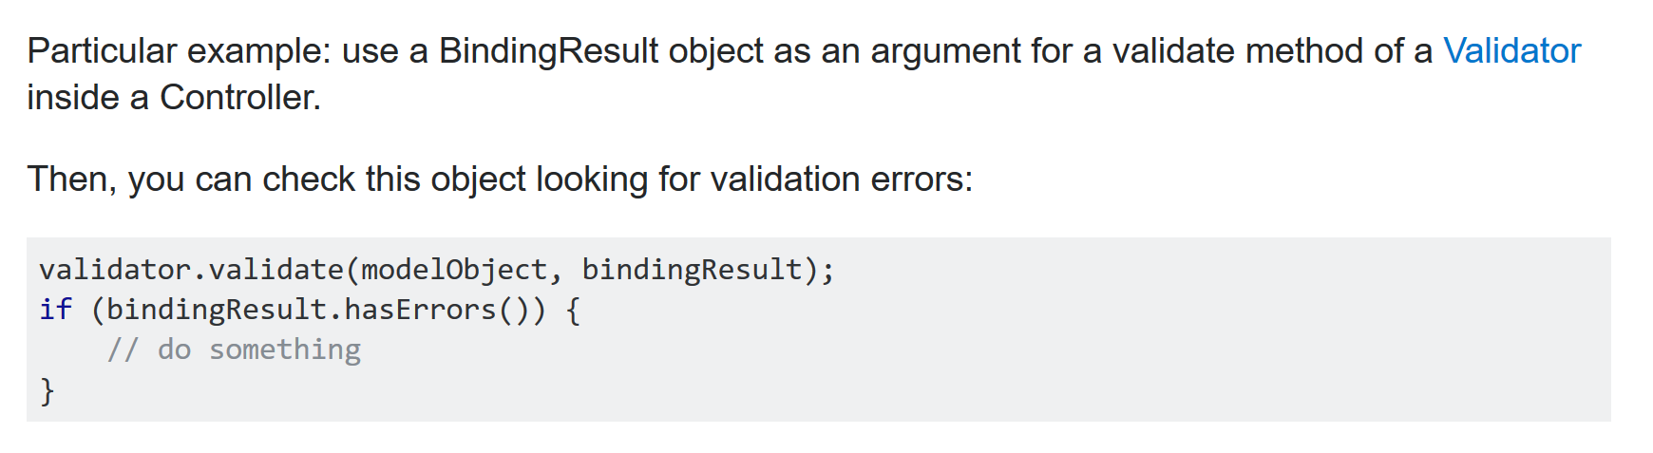

<https://stackoverflow.com/questions/10413886/what-is-the-use-of-bindingresult-interface-in-spring-mvc>

1. How do you map validation results to your view?

<http://www.codejava.net/frameworks/spring/spring-mvc-form-validation-example-with-bean-validation-api>

1. What are Spring Form Tags?

Spring's form tag accesses to the command object, and. also it refers to the data our Spring controller deals with. A Command object can be. defined as a JavaBean that stores user input, usually entered through HTML form is. called the Command object.

1. What is a Path Variable?

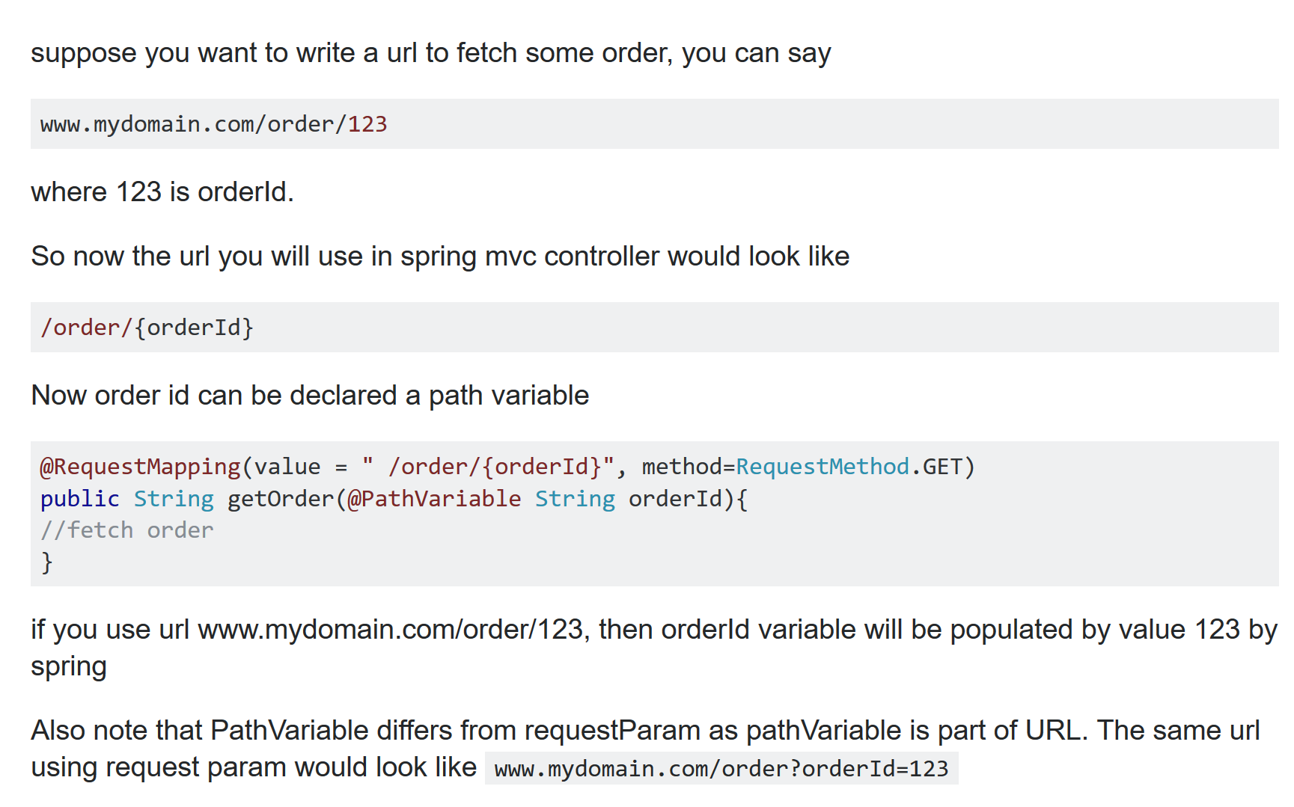

<https://stackoverflow.com/questions/19803731/spring-mvc-pathvariable>

1. What is a Model Attribute?

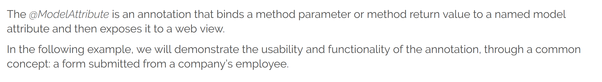

<http://www.baeldung.com/spring-mvc-and-the-modelattribute-annotation>

1. What is a Session Attribute?

<http://www.baeldung.com/spring-mvc-session-attributes>

1. What is a init binder?

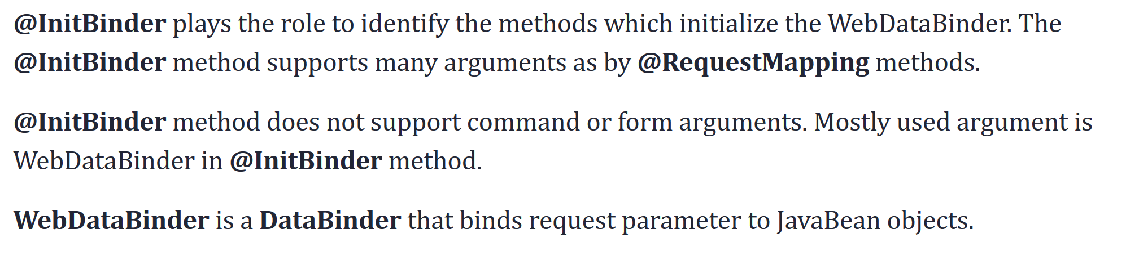

<https://dzone.com/articles/spring-initbinder-for-handling-large-list-of-java>

1. How do you set default date format with Spring?

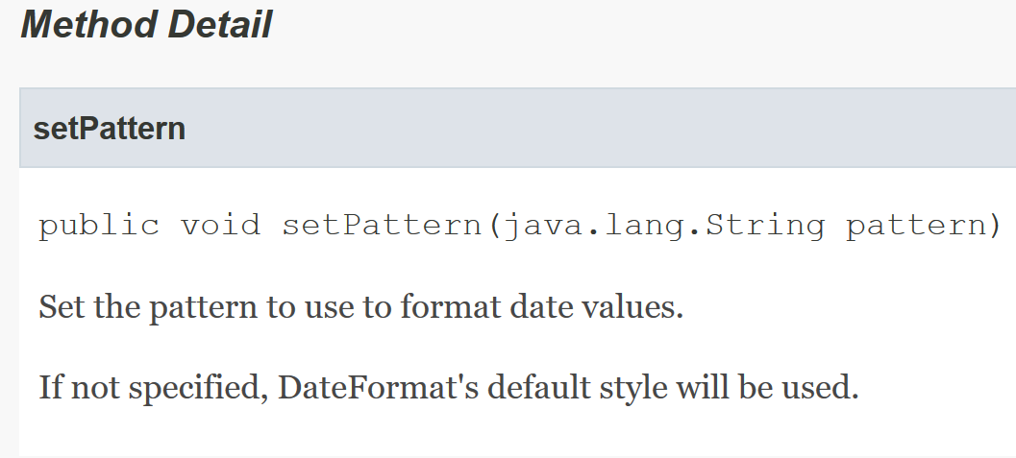

<https://docs.spring.io/spring-framework/docs/current/javadoc-api/org/springframework/format/datetime/DateFormatter.html>

1. Why is Spring MVC so popular?

* Developer-Friendly
* Integration With Front-End Technology
* Aspect Oriented Programming
* MVC Framework

<https://www.freelancinggig.com/blog/2018/04/26/spring-popular-java-frameworks/>

1. Spring Boot

All in all, Spring Boot is a project built on the top of the Spring framework. It provides a simpler and faster way to set up, configure, and run both simple and web-based applications.

Features -

Auto-configuration: It sets up your application based on the surrounding environment, as well as hints what the developers provide.

Standalone: Literally, it's completely standalone. Hence, you don’t need to deploy your application to a web server or any special environment. Your only task is to click on the button or give out the run command, and it will start.

Opinionated: This means that the framework chooses how to things for itself. This is the point where a lot of people says "wait a minute, I do not want to participate in it." Here I encourage you to wait for a second and hold your judgment for now, because, actually, it can be a good thing.

1. What are the important Goals of Spring Boot?

* Provide a radically faster and widely accessible getting-started experience for all Spring development.
* Be opinionated out of the box but get out of the way quickly as requirements start to diverge from the defaults.
* Provide a range of non-functional features that are common to large classes of projects (such as embedded servers, security, metrics, health checks, and externalized configuration).
* Absolutely no code generation and no requirement for XML configuration.

1. What are the important Features of Spring Boot?

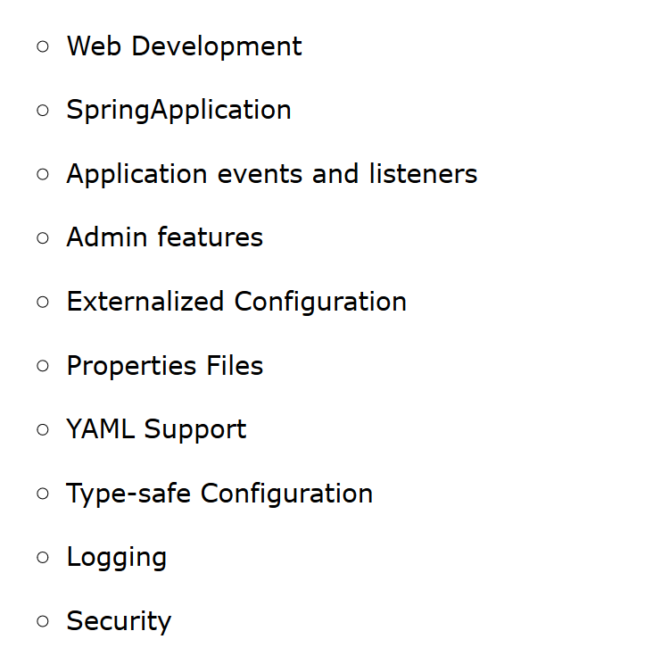

<https://www.javatpoint.com/spring-boot-features>

1. Compare Spring Boot vs Spring?
2. Compare Spring Boot vs Spring MVC?

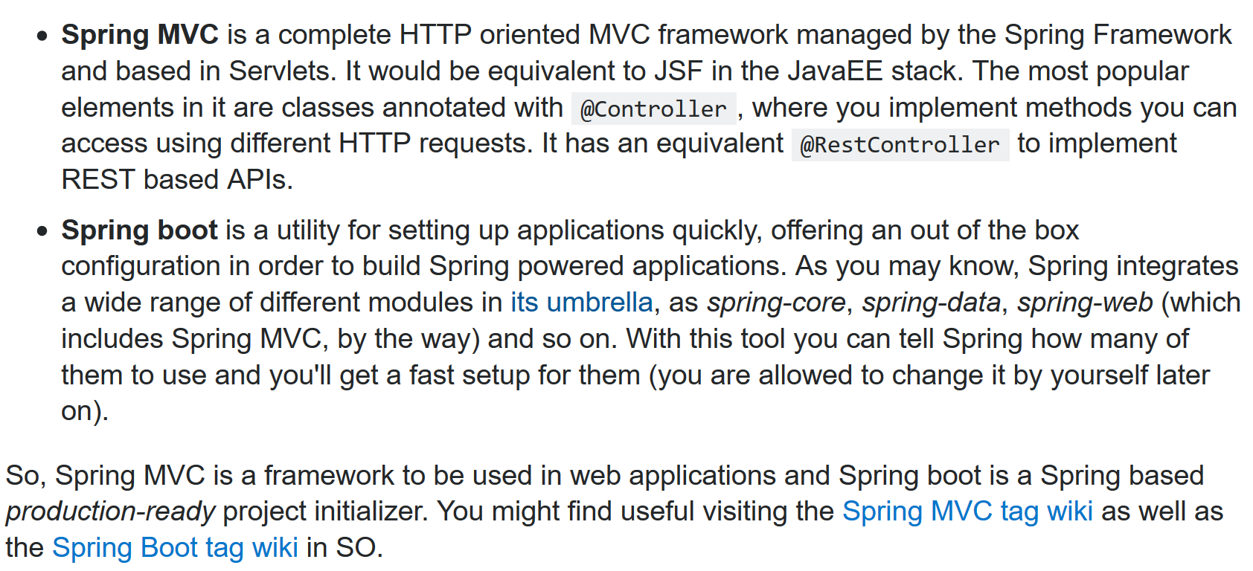

<https://stackoverflow.com/questions/32922914/difference-between-spring-mvc-and-spring-boot>

1. What is the importance of @SpringBootApplication?

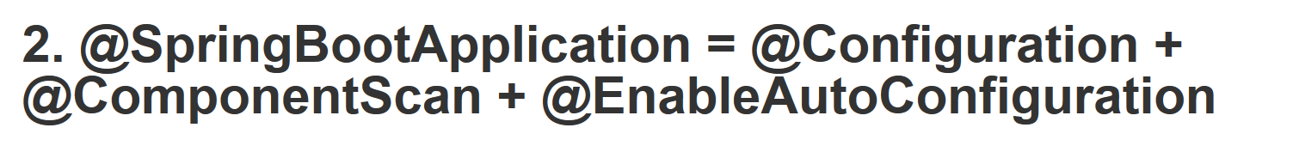

<https://javarevisited.blogspot.com/2018/05/the-springbootapplication-annotation-example-java-spring-boot.html>

1. What is Auto Configuration?

<http://www.springboottutorial.com/spring-boot-auto-configuration>

<https://dzone.com/articles/what-is-spring-boot-auto-configuration>

1. How can we find more information about Auto Configuration?
2. What is an embedded server? Why is it important?

An embedded HTTP server is a component of a software system that implements the HTTP protocol. Examples of usage within an application might be: To provide a thin client interface for a traditional application. To provide indexing, reporting, and debugging tools during the development stage.

1. What is the default embedded server with Spring Boot?

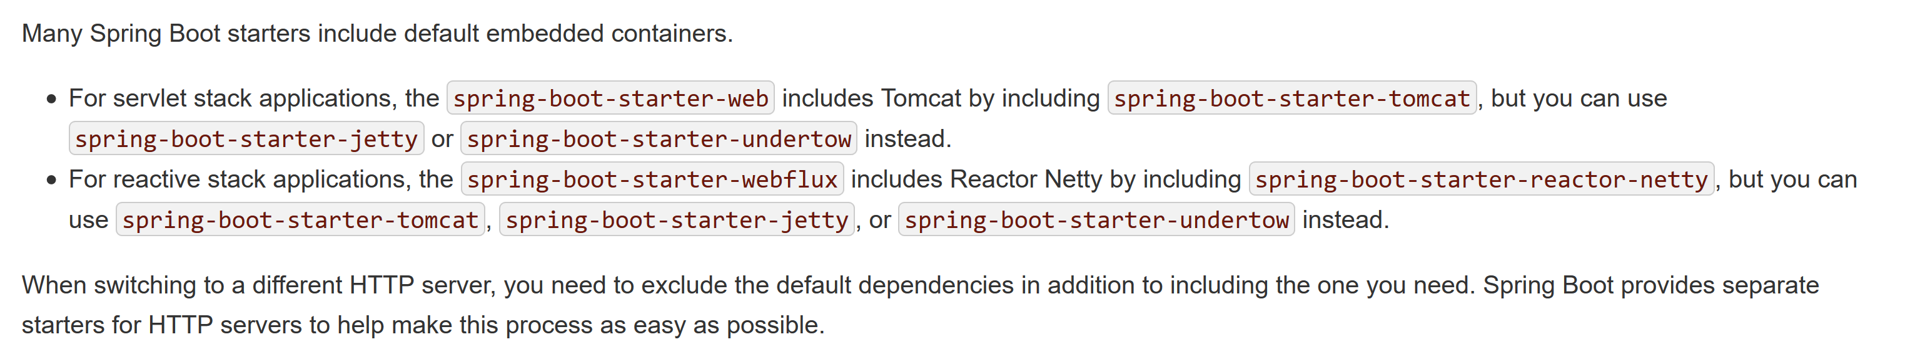

<https://docs.spring.io/spring-boot/docs/current/reference/html/howto-embedded-web-servers.html>

1. What are the other embedded servers supported by Spring Boot?
2. What are Starter Projects?

<http://www.springboottutorial.com/spring-boot-starter-projects>

1. Can you give examples of important starter projects?

<http://www.springboottutorial.com/spring-boot-starter-projects>

1. What is Starter Parent?

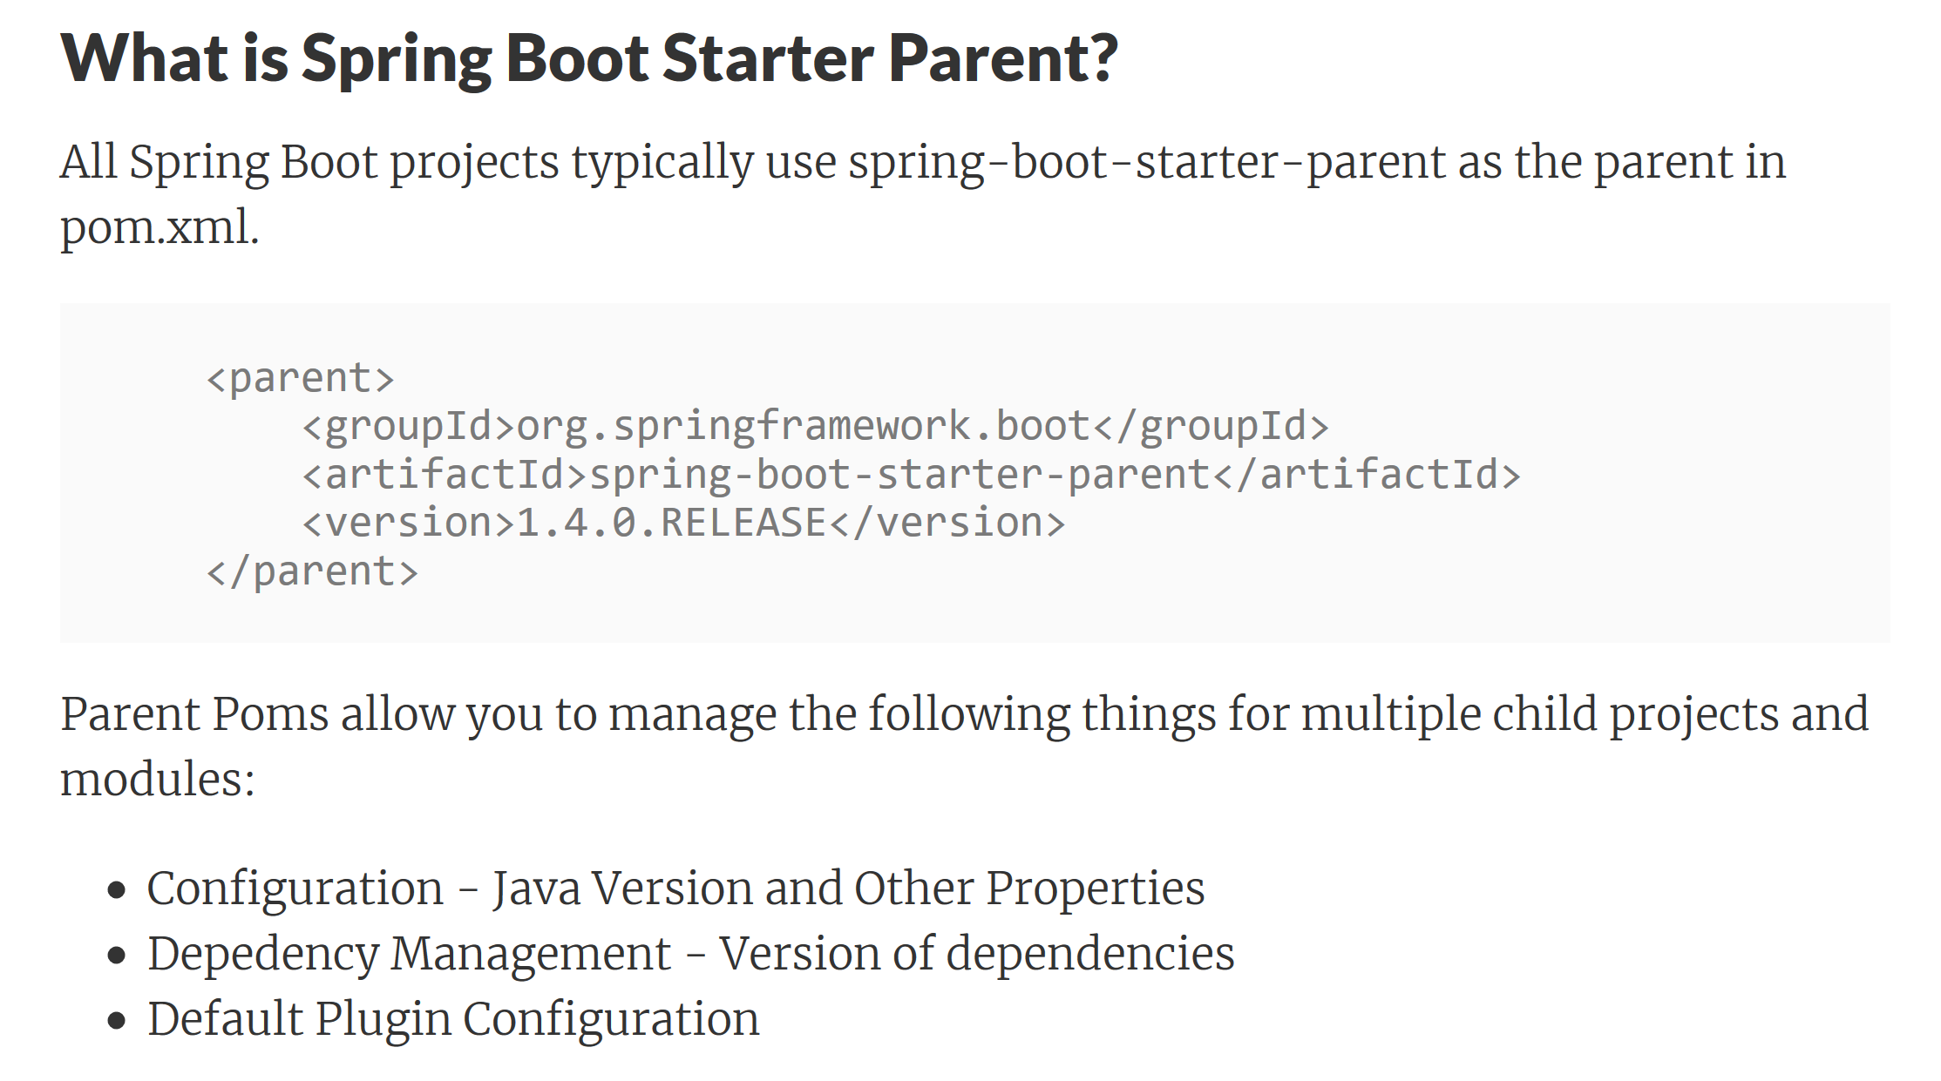

<http://www.springboottutorial.com/spring-boot-starter-parent>

1. What are the different things that are defined in Starter Parent?

<http://www.springboottutorial.com/spring-boot-starter-parent>

1. How does Spring Boot enforce common dependency management for all its Starter projects?

<https://docs.spring.io/spring-boot/docs/current/reference/html/using-boot-build-systems.html>

1. What is Spring Initializr?

<https://www.javatpoint.com/spring-initializr>

It is a web tool which is provided by Spring on official site. You can create Spring Boot project by providing project details.

Select Maven project and dependencies. Fill other details and click on generate project.

1. What is application.properties?

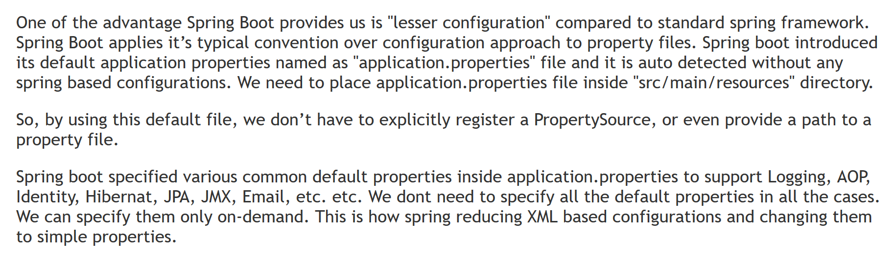

1. What are some of the important things that can customized in application.properties?

<https://docs.spring.io/spring-boot/docs/current/reference/html/boot-features-external-config.html>

1. How do you externalize configuration using Spring Boot?

<https://docs.spring.io/spring-boot/docs/current/reference/html/howto-properties-and-configuration.html>

1. How can you add custom application properties using Spring Boot?
2. What is @ConfigurationProperties?

<http://www.baeldung.com/configuration-properties-in-spring-boot>

1. What is a profile?

<https://www.mkyong.com/spring-boot/spring-boot-profiles-example/>

1. How do you define beans for a specific profile?
2. How do you create application configuration for a specific profile?
3. How do you have different configuration for different environments?
4. What is Spring Boot Actuator?

The Spring Boot Actuator is a sub-project of Spring Boot project. It is built to collect and monitor application information. You can embed it in your application and use its features. To monitor the application you need to access the built-in endpoints of the Spring Boot Actuator , and you can also create your own endpoints if you want.

1. How do you monitor web services using Spring Boot Actuator?
2. How do you find more information about your application envrionment using Spring Boot?
3. What is a CommandLineRunner?
4. Database Connectivity - JDBC, Spring JDBC & JPA

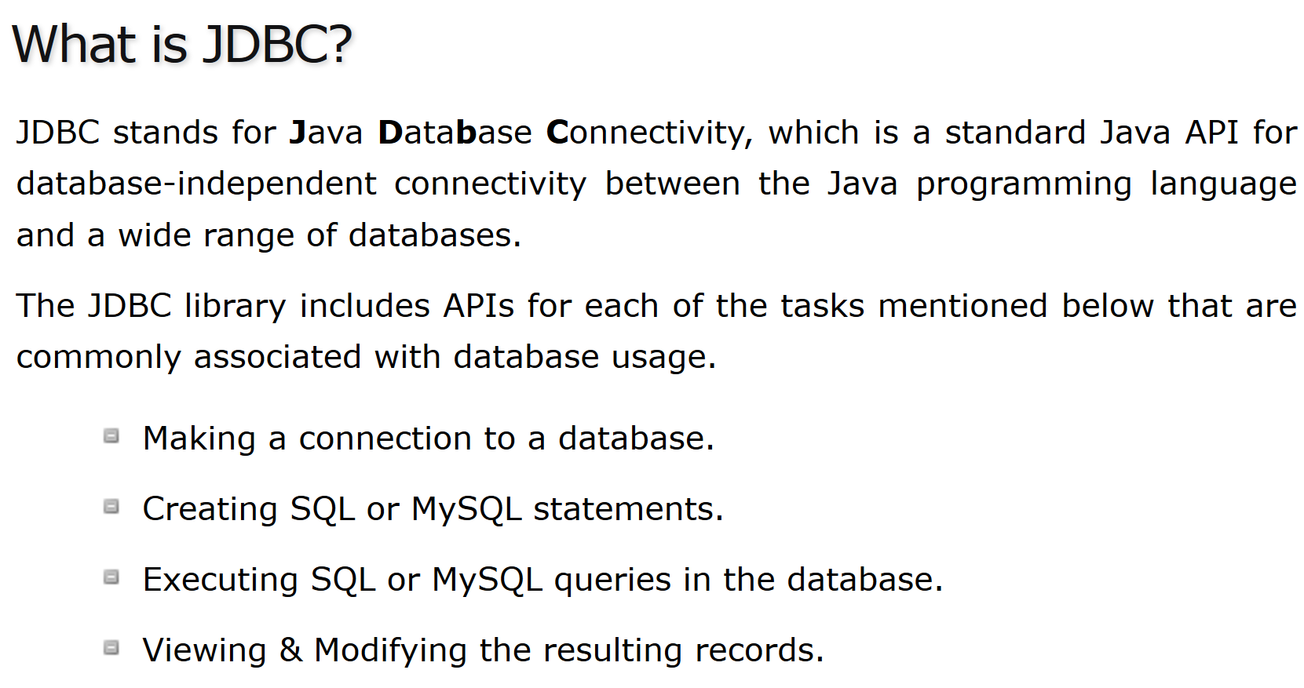

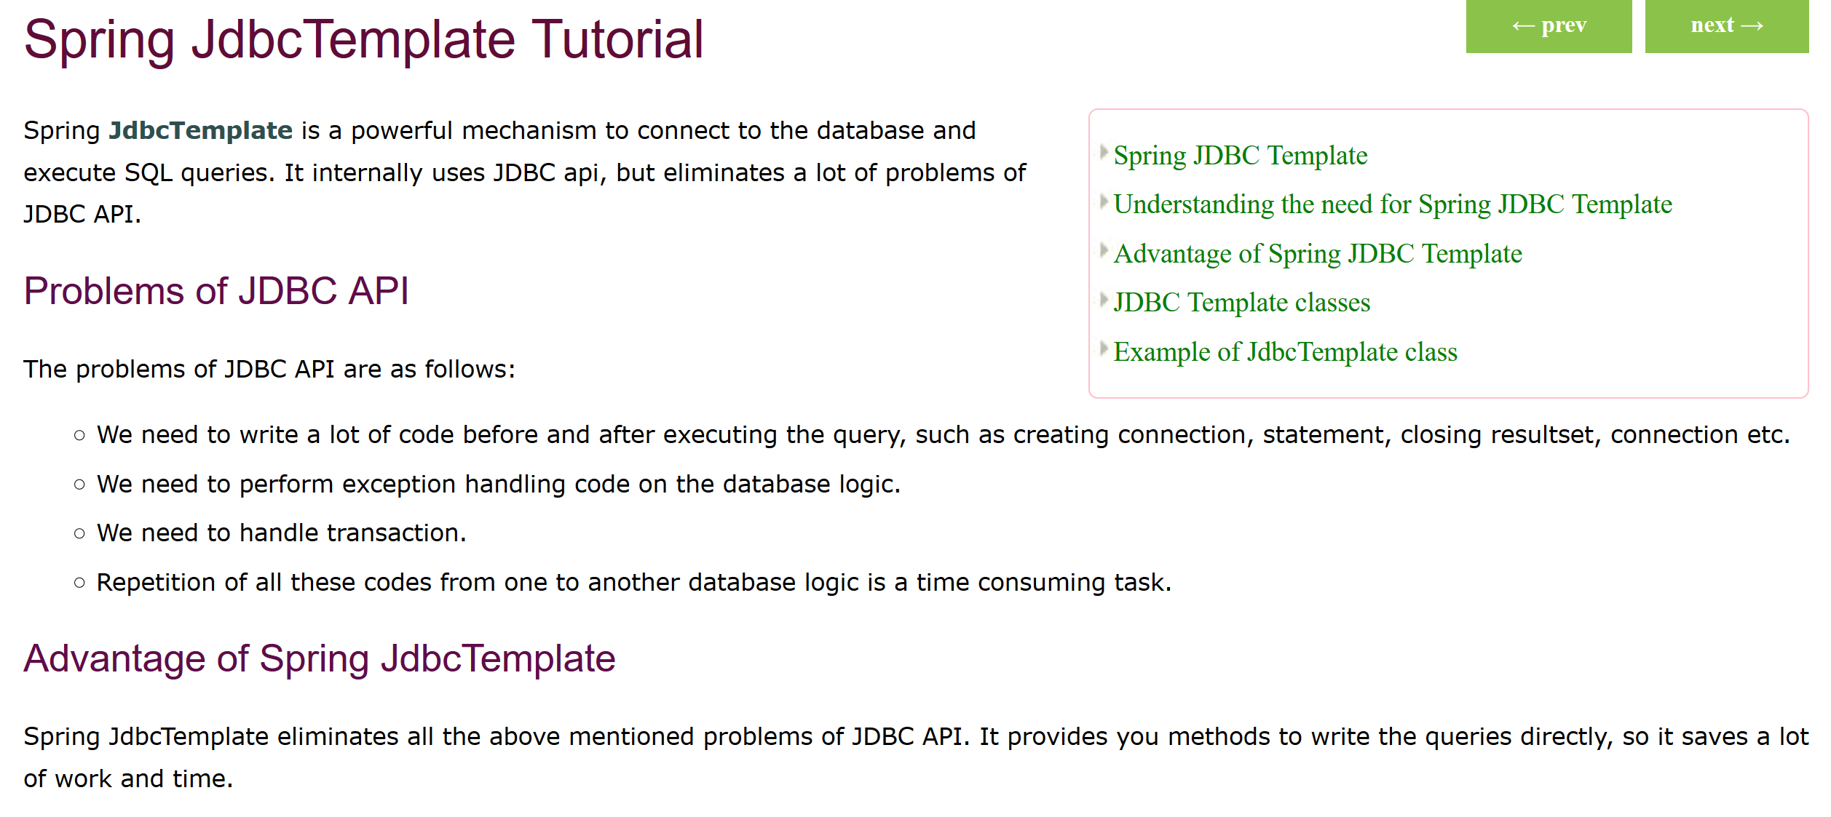

Java Persistence API is a collection of classes and methods to persistently store the vast amounts of data into a database which is provided by the Oracle Corporation.

1. What is Spring JDBC? How is different from JDBC?
2. What is a JdbcTemplate?
3. What is a RowMapper?
4. What is JPA?

It forms a bridge between object models (Java program) and relational models (database program).

1. **What is Hibernate?**

Hibernate ORM is an object-relational mapping tool for the Java programming language. It provides a framework for mapping an object-oriented domain model to a relational database.

1. **How do you define an entity in JPA?**

JPA Entity classes are user defined classes whose instances can be stored in a database.

To store data in an ObjectDB database using JPA you have to define entity classes that represent your application data object model.

1. What is an Entity Manager?

An EntityManager instance is associated with a persistence context. ... Within the persistence context, the entity instances and their lifecycle are managed. The EntityManager API is used to create and remove persistent entity instances, to find entities by their primary key, and to query over entities.

1. **What is a Persistence Context?**

A persistence context is a set of entities such that for any persistent identity there is a unique entity instance. Within a persistence context, entities are managed. The EntityManager controls their lifecycle, and they can access datastore resources.

1. How do you map relationships in JPA?

<https://www.javaworld.com/article/2077819/java-se/understanding-jpa-part-2-relationships-the-jpa-way.html>

1. What are the different types of relationships in JPA? 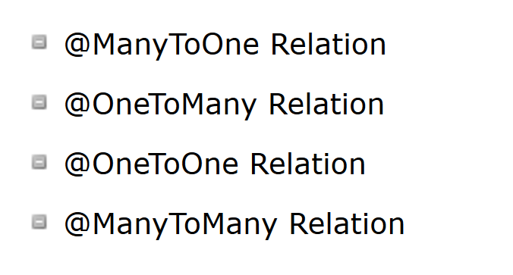
2. How do you define One to One Mapping in JPA?

<https://www.tutorialspoint.com/jpa/jpa_entity_relationships.htm>

1. How do you define One to Many Mapping in JPA?

<https://www.tutorialspoint.com/jpa/jpa_entity_relationships.htm>

1. How do you define Many to Many Mapping in JPA?

<https://www.tutorialspoint.com/jpa/jpa_entity_relationships.htm>

1. How do you define a datasource in a Spring Context?
2. What is the use of persistence.xml
3. How do you configure Entity Manager Factory and Transaction Manager?
4. How do you define transaction management for Spring – Hibernate integration?
5. **What is Spring Data?**

Spring Data is a high level SpringSource project whose purpose is to unify and ease the access to different kinds of persistence stores, both relational database systems and NoSQL data stores.

1. What is the need for Spring Data?
2. What is Spring Data JPA?

<https://www.petrikainulainen.net/spring-data-jpa-tutorial/>

1. What is a CrudRepository?

<https://www.concretepage.com/spring-5/spring-data-crudrepository-example>

1. What is a PagingAndSortingRepository?
2. Unit Testing
3. How does Spring Framework Make Unit Testing Easy?
4. What is Mockito?
5. What is your favorite mocking framework?
6. How do you do mock data with Mockito?
7. What are the different mocking annotations that you worked with?
8. What is MockMvc?
9. What is @WebMvcTest?
10. **What is @MockBean?**

@MockBean

The newly introduced annotation, (@MockBean), adds generalized support for mocking of any Spring bean. If you've used Mockito Annotations before, @MockBean is simliar to @Mock but with Spring support.

Suppose we have a simple @Component-annoated class called DailyWeather and a simple @Service-annotated class called WeatherService. Additionally, the DailyWeatherclass relies on the WeatherService as a dependency and is injected via the constructor.

To unit test the DailyWeather component, you can mock the WeatherService dependency by simply annotating it with @MockBean and then use Mockito.when(..) like normal.

1. How do you write a unit test with MockMVC?
2. What is JSONAssert?
3. How do you write an integration test with Spring Boot?
4. **What is @SpringBootTest?**

The @SpringBootTest annotation tells Spring Boot to go and look for a main configuration class (one with @SpringBootApplication for instance), and use that to start a Spring application context. You can run this test in your IDE or on the command line (mvn test or gradle test) and it should pass. To convince yourself that the context is creating your controller you could add an assertion

1. **What is @LocalServerPort?**

Annotation at the field or method/constructor parameter level that injects the HTTP port that got allocated at runtime. Provides a convenient alternative for @Value("${local.server.port}").

1. **What is TestRestTemplate?**

<https://www.baeldung.com/spring-boot-testresttemplate>

1. **AOP**

Aspect-oriented programming is a programming paradigm that aims to increase modularity by allowing the separation of cross-cutting concerns

1. **What are cross cutting concerns?**

The crosscutting concern is a concern which is applicable throughout the application and it affects the entire application. For example: logging, security and data transfer are the concerns which are needed in almost every module of an application, hence they are cross-cutting concerns.

1. **How do you implement cross cutting concerns in a web application?**

<https://www.javaworld.com/article/2077666/web-app-frameworks/implement-crosscutting-concerns-using-spring-2-0-aop.html>

1. If you would want to log every request to a web application, what are the options you can think of?
2. If you would want to track performance of every request, what options can you think of?
3. What is an Aspect and Pointcut in AOP?
4. **What is an Aspect and Pointcut in AOP?**

Aspect: a modularization of a concern that cuts across multiple classes. Transaction management is a good example of a crosscutting concern in J2EE applications. In Spring AOP, aspects are implemented using regular classes (the schema-based approach) or regular classes annotated with the @Aspect annotation (the @AspectJ style).

Pointcut: a predicate that matches join points. Advice is associated with a pointcut expression and runs at any join point matched by the pointcut (for example, the execution of a method with a certain name). The concept of join points as matched by pointcut expressions is central to AOP, and Spring uses the AspectJ pointcut expression language by default.

<https://docs.spring.io/spring/docs/2.5.x/reference/aop.html>

1. What are the different types of AOP advices?

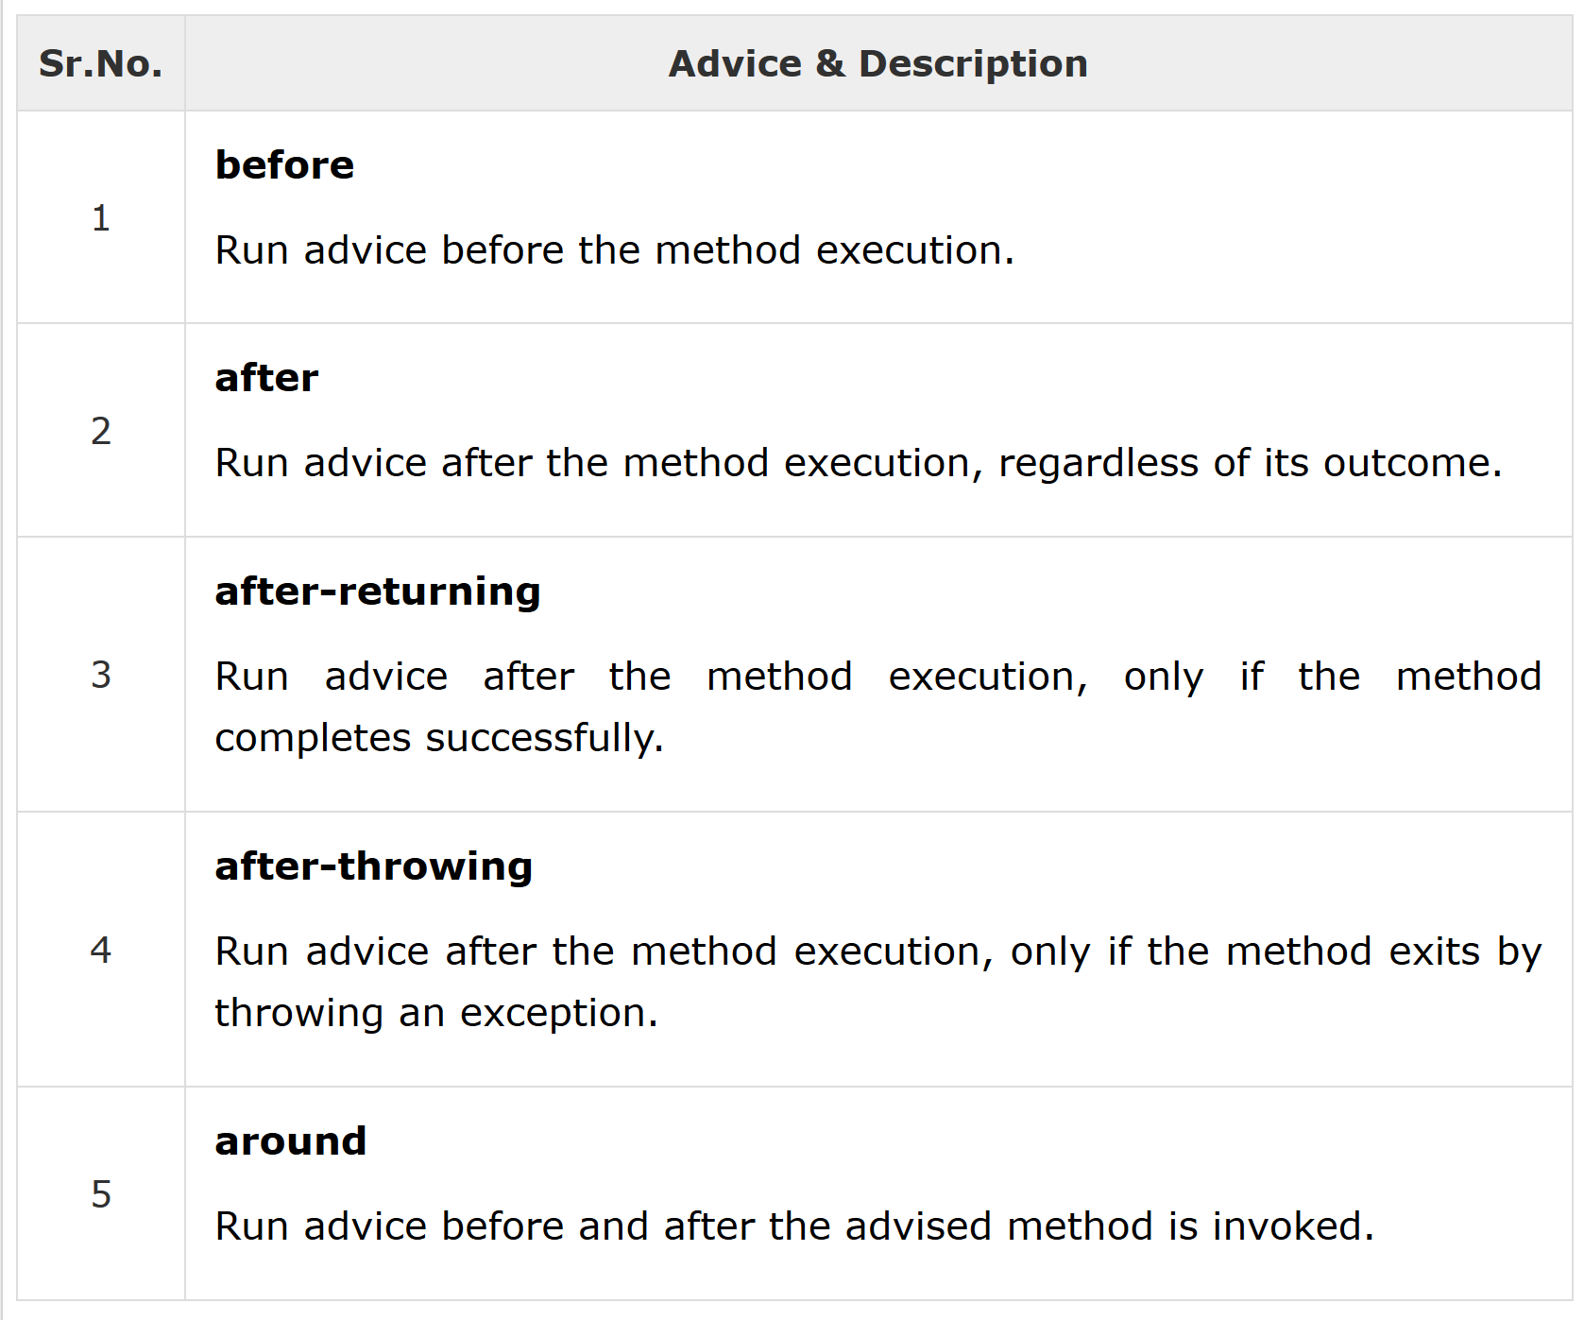

<https://www.tutorialspoint.com/springaop/springaop_advice_types.htm>

1. What is weaving?

Weaving: linking aspects with other application types or objects to create an advised object. This can be done at compile time (using the AspectJ compiler, for example), load time, or at runtime. Spring AOP, like other pure Java AOP frameworks, performs weaving at runtime.

1. Compare Spring AOP vs AspectJ?

<https://www.baeldung.com/spring-aop-vs-aspectj>

1. What is a Web Service?

The term Web services describes a standardized way of integrating Web-based applications using the XML, SOAP, WSDL and UDDI open standards over an Internet protocol backbone. XML is used to tag the data, SOAP is used to transfer the data, WSDL is used for describing the services available and UDDI is used for listing what services are available. Used primarily as a means for businesses to communicate with each other and with clients, Web services allow organizations to communicate data without intimate knowledge of each other's IT systems behind the firewall.

<https://www.webopedia.com/TERM/W/Web_Services.html>

1. What is SOAP Web Service?
2. **What is SOAP?**

SOAP is an acronym for Simple Object Access Protocol. It is an XML-based messaging protocol for exchanging information among computers. SOAP is an application of the XML specification.

1. **What is a SOAP Envelope?**

SOAP provides the Messaging Protocol layer of a web services protocol stack for web services. It is an XML-based protocol consisting of three parts: an envelope, which defines the message structure and how to process it.

1. **What is SOAP Header and SOAP Body?**

Header: It is an optional part of a SOAP message. Header elements can occur multiple times. Headers are intended to add new features and functionality. The SOAP header contains header entries defined in a namespace. The header is encoded as the first immediate child element of the SOAP envelope.

Body: The SOAP body is a mandatory element that contains the application-defined XML data being exchanged in the SOAP message. The body must be contained within the envelope and must follow any headers that might be defined for the message. The body is defined as a child element of the envelope, and the semantics for the body are defined in the associated SOAP schema.

1. Can you give an example of SOAP Request and SOAP Response?
2. What is a SOAP Header? What kind of information is sent in a SOAP Header?
3. Can you give an example of a SOAP Header with Authentication information?
4. What is WSDL (Web Service Definition Language)?
5. What are the different parts of a WSDL?
6. What is Contract First Approach?
7. **What is an XSD?**

XSD (XML Schema Definition) is a World Wide Web Consortium (W3C) recommendation that specifies how to formally describe the elements in an Extensible Markup Language (XML) document.

1. **Can you give an example of an XSD?**

XML

1. **What is JAXB?**

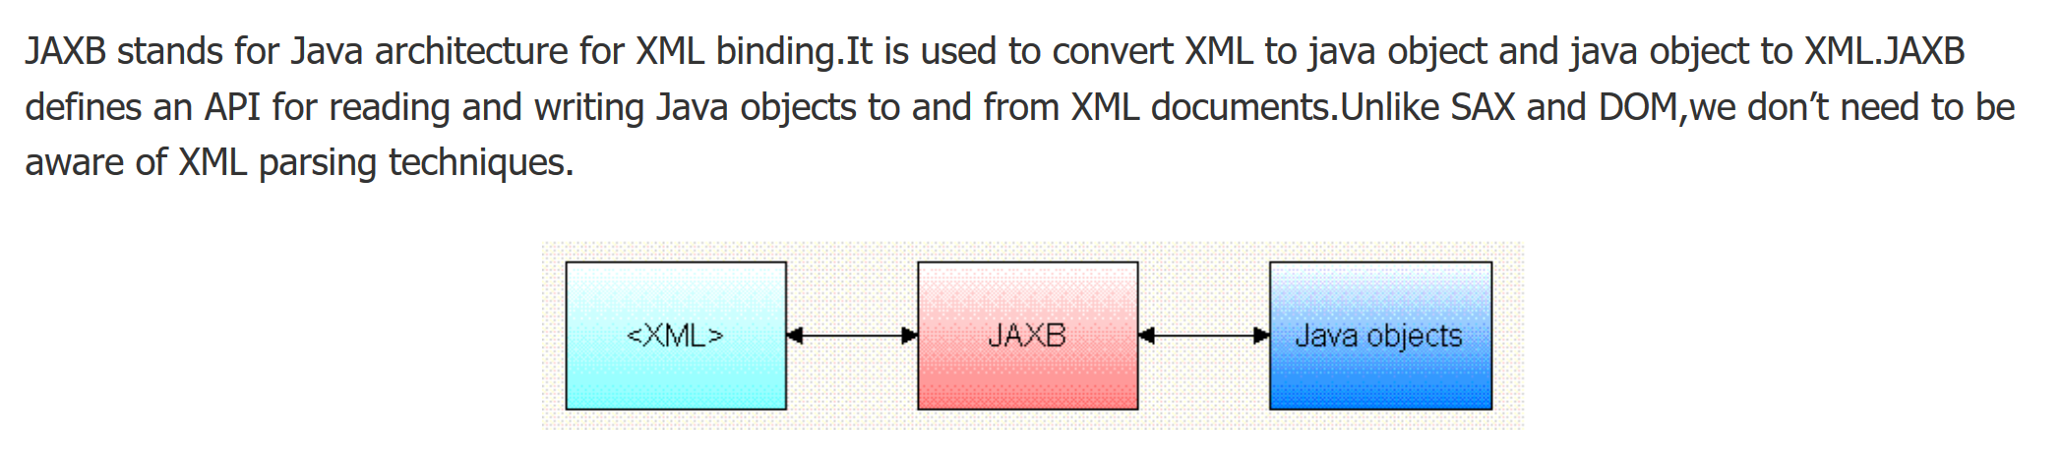

1. How do you configure a JAXB Plugin?
2. What is an Endpoint?

The Web service endpoint is the port upon which you connect a Web service client to the Orchestrator server. You connect to the Orchestrator Web service's endpoint at the following URL, in which orchestrator_server is the IP address or host name of the host on which the Orchestrator server is running.

1. Can you show an example endpoint written with Spring Web Services?

<http://www.springboottutorial.com/creating-soap-web-service-with-spring-boot-web-services-starter>

1. What is a MessageDispatcherServlet?

Spring-WS's server-side support is designed around a MessageDispatcher that dispatches incoming messages to endpoints, with configurable endpoint mappings, response generation, and endpoint interception. Endpoints are typically annotated with the @Endpoint annotation, and have one or more handling methods. These methods handle incoming XML request messages by inspecting parts of the message (typically the payload), and create some sort of response. You annotate the method with another annotation, typically @PayloadRoot, to indicate what sort of messages it can handle.

The server-side of Spring-WS is designed around a central class that dispatches incoming XML messages to endpoints. Spring-WS's MessageDispatcher is extremely flexible, allowing you to use any sort of class as an endpoint, as long as it can be configured in the Spring IoC container. In a way, the message dispatcher resembles Spring's DispatcherServlet, the “Front Controller” used in Spring Web MVC.

1. How do you configure a MessageDispatcherServlet?

<https://stackoverflow.com/questions/26464931/how-to-configure-messagedispatcherservlet-programtically>

1. How do you generate a WSDL using Spring Web Services?
2. How do you implement error handling for SOAP Web Services?

<http://www.informit.com/articles/article.aspx?p=26666&seqNum=9>

1. What is a SOAP Fault?

<https://whatis.techtarget.com/definition/SOAP-fault>

1. RESTful Web Services
2. What is REST?
3. What are the key concepts in designing RESTful API?

<https://dzone.com/articles/5-basic-rest-api-design-guidelines>

1. What are the Best Practices of RESTful Services?

<https://blog.mwaysolutions.com/2014/06/05/10-best-practices-for-better-restful-api/>

1. Can you show the code for an example Get Resource method with Spring REST?
2. What happens when we return a bean from a Request Mapping Method?
3. **What is** **GetMapping and what are the related methods available in Spring MVC?**

<https://howtodoinjava.com/spring5/webmvc/controller-getmapping-postmapping/>

1. Can you show the code for an example Post Resource method with Spring REST?
2. **What is the appropriate HTTP Response Status for successful execution of a Resource Creation?**

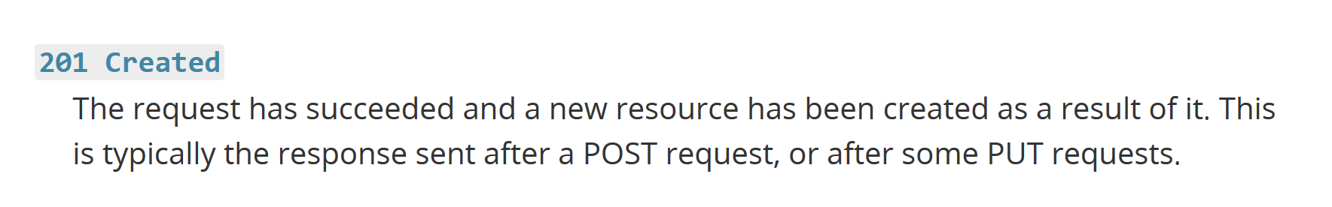

1. Why do we use ResponseEntity in a RESTful Service?

<http://zetcode.com/springboot/responseentity/>

1. What is HATEOAS?

<https://spring.io/understanding/HATEOAS>

1. Can you give an Example Response for HATEOAS?

<https://spring.io/understanding/HATEOAS>

1. How do we implement it using Spring?

<https://www.baeldung.com/spring-hateoas-tutorial>

1. **How do you document RESTful web services?**

Swagger UI

1. **Can you give a brief idea about Swagger Documentation?**

A Swagger document is the REST API equivalent of a WSDL document for a SOAP-based web service. The Swagger document specifies the list of resources that are available in the REST API and the operations that can be called on those resources.

1. How do you automate generation of Swagger Documentation from RESTful Web Services?
2. How do you add custom information to Swagger Documentation generated from RESTful Web Services?
3. What is Swagger-UI?

The Swagger UI is an open source project to visually render documentation for an API defined with the OpenAPI (Swagger) Specification. Swagger UI lets you visualize and interact with the API’s resources without having any of the implementation logic in place, making it easy for back end implementation and client side consumption.

1. What is "Representation" of a Resource?

<https://stackoverflow.com/questions/33706191/what-is-the-difference-between-resource-and-resource-representation-in-rest>

1. What is Content Negotiation?

<https://spring.io/blog/2013/05/11/content-negotiation-using-spring-mvc>

1. Which HTTP Header is used for Content Negotiation?

<http://restlet.com/company/blog/2015/12/10/understanding-http-content-negotiation/>

1. How do we implement it using Spring Boot?

<https://www.baeldung.com/spring-mvc-content-negotiation-json-xml>

1. How do you add XML support to your RESTful Services built with Spring Boot?

<https://stackoverflow.com/questions/32654291/spring-boot-rest-with-xml-support>

1. How do you implement Exception Handling for RESTFul Web Services?

<https://www.baeldung.com/exception-handling-for-rest-with-spring>

1. What are the best practices related to Exception Handling with respect to RESTful Web Services?

<https://blog.restcase.com/rest-api-error-codes-101/>

1. What are the different error status that you would return in RESTful Web Services?

<https://restfulapi.net/http-status-codes/>

1. How would you implement them using Spring Boot?

<https://www.toptal.com/java/spring-boot-rest-api-error-handling>

1. What HTTP Response Status do you return for validation errors?

<https://stackoverflow.com/questions/3290182/rest-http-status-codes-for-failed-validation-or-invalid-duplicate>

1. How do you handle Validation Errors with RESTful Web Services?

<http://www.springboottutorial.com/spring-boot-validation-for-rest-services>

1. Why do we need Versioning for RESTful Web Services?

<http://www.springboottutorial.com/spring-boot-versioning-for-rest-services>

1. What are the versioning options that are available?

<https://www.xmatters.com/integrations/blog-four-rest-api-versioning-strategies/>

1. How do you implement Versioning for RESTful Web Services?

<https://www.baeldung.com/rest-versioning>

1. **Spring Security**

<https://www.youtube.com/watch?v=rOnoKiH97Nc>

In this Spring Boot Security tutorial I show you how to secure your RESTful endpoints & controllers with spring security. I first start off my creating a standard spring boot project and add a couple of RESTful endpoints via spring’s @RestController and @RequestMapping annotations.

At this stage spring security is not on the classpath so the URLs are all open to HTTP requests. I then add the spring-boot-starter-security dependency to the classpath via a simple maven dependency and perform a project update. If spring security is on the classpath then the web application will automatically be secured with basic authentication on all HTTP endpoints when there is no bean annotated with @EnableWebSecurity.

The default username and password is ‘user’ and a random UUID password is generated each time the application starts, you can see this in the start-up logs. Do not use this in production. After showing the automatic spring security basic authentication on all endpoints, I then create a java class annotated with @**EnableWebSecurity**. The class SecurityConfig extends **WebSecurityConfigurerAdapter** and overrides the configure(**HttpSecurity** http) method. This method disables the default HTTP Spring Security and allows us to define our own fine grained http security on our RESTful endpoints.

I specified that the ant path expressions endpoints must have the defined roles associated with the login credentials. Within the bean annotated with EnableWebSecurity, I added and autowired an configureGlobal(**AuthenticationManagerBuilder** auth) method. This allows you to specify the type of authentication manager (LDAP, In-memory, Token based etc). I added two users with different roles and demo the application returning an http 403 unauthorized when an authenticated but unauthorized user attempted to access a specific endpoint.

1. **Creating REST clients to consume REST API endpoints**

<https://www.youtube.com/watch?v=gJzXyVXuHTY>

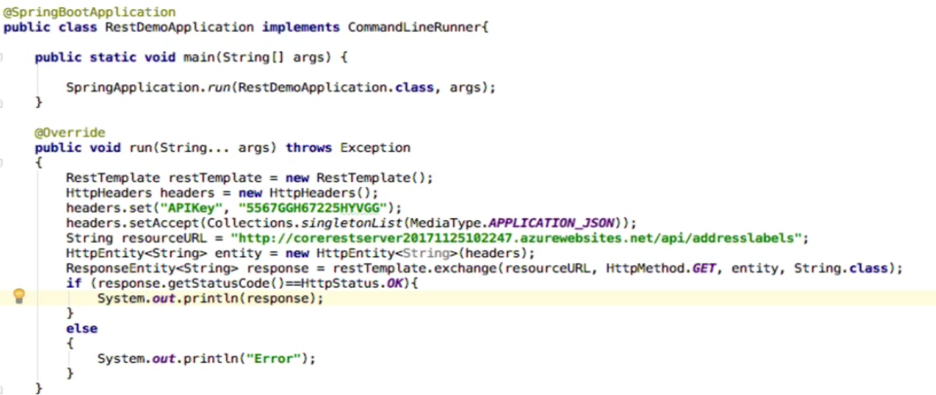

1. How do you track REST API usage?

Using KONG.

<https://www.youtube.com/watch?v=qsntYnW3Zzg>

1. Best practices for designing secure REST Api

<https://restfulapi.net/security-essentials/>

1. Best Practices for Resource Representation in REST
2. How do you perform validation in REST
3. Good practices for API design

<https://medium.com/hashmapinc/rest-good-practices-for-api-design-881439796dc9>

1. Bean Life Cycle

<https://www.youtube.com/watch?v=_tCX2TFIv6k>

<https://www.youtube.com/watch?v=CZzmmP2Soy4>

1. Layers

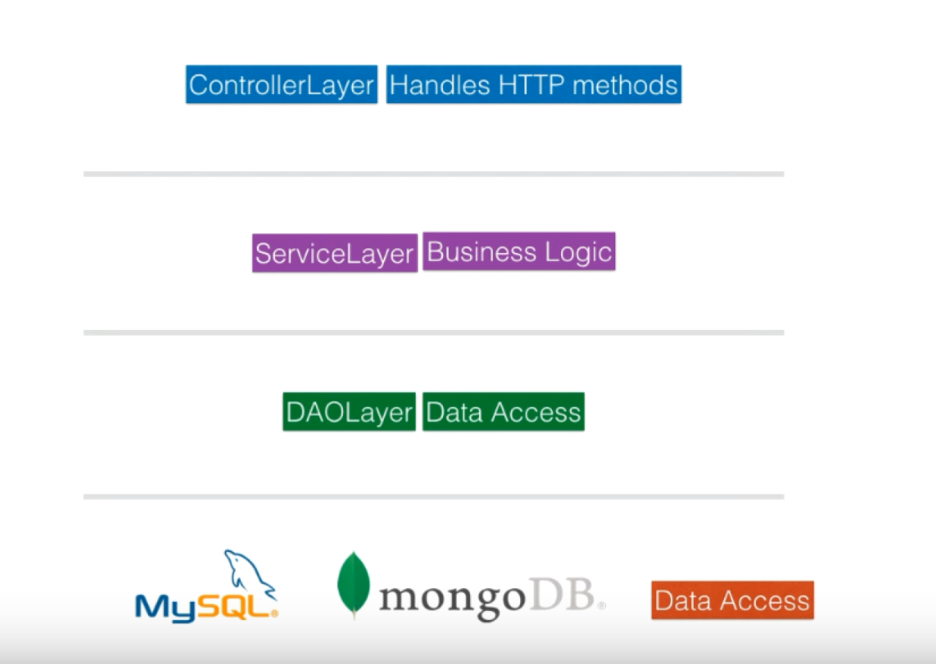

1. **What is Maven?**

Ans: Apache Maven is a software project management and comprehension tool. Based on the concept of a project object model (POM), Maven can manage a project's build, reporting and documentation from a central piece of information.

1. **What is Web Service?**

A Web service is a software system designed to support interoperable machine-to-machine interaction over a network. In common usage the term refers to clients and servers that communicate over the Hypertext Transfer Protocol (HTTP) protocol used on the Web

1. **What is GIT?**

Ans: Git is a free and open source distributed version control system designed to handle everything from small to very large projects with speed and efficiency.

Git is easy to learn and has a tiny footprint with lightning fast performance. It outclasses SCM tools like Subversion, CVS, Perforce, and ClearCase with features like cheap local branching, convenient staging areas, and multiple workflows.

1. **What is Jenkins?**

Ans: Jenkins offers a simple way to set up a continuous integration or continuous delivery environment for almost any combination of languages and source code repositories using pipelines, as well as automating other routine development tasks.

1. **What is Nginx?**

Ans: NGINX is open source software for web serving, reverse proxying, caching, load balancing, media streaming, and more.

1. **What is Docker?**

Ans: [Docker](https://github.com/docker/docker) is a tool designed to make it easier to create, deploy, and run applications by using containers. Containers allow a developer to package up an application with all of the parts it needs, such as libraries and other dependencies, and ship it all out as one package. By doing so, thanks to the container, the developer can rest assured that the application will run on any other Linux machine regardless of any customized settings that machine might have that could differ from the machine used for writing and testing the code.

1. **What is Docker Swarm?**

Ans: Docker Swarm is a clustering and scheduling tool for [Docker](https://searchitoperations.techtarget.com/definition/Docker) containers. With Swarm, IT administrators and developers can establish and manage a [cluster](https://searchexchange.techtarget.com/definition/cluster) of Docker nodes as a single virtual system. An IT administrator controls Swarm through a swarm manager, which orchestrates and schedules containers. The swarm manager allows a user to create a primary manager [instance](https://whatis.techtarget.com/definition/instance) and multiple replica instances in case the primary instance fails. In Docker Engine's swarm mode, the user can deploy manager and worker nodes at runtime.

1. **What is AWS?**

Ans: Amazon Web Services (AWS) is a secure [cloud](https://aws.amazon.com/what-is-cloud-computing/) services platform, offering compute power, database storage, content delivery and other functionality to help businesses scale and grow.

1. **What is Spring?**

Ans: The Spring Framework is an application framework and inversion of control container for the Java platform.

1. **What is Spring MVC?**

Ans: Spring - MVC Framework. Advertisements. The SpringWeb MVC framework provides Model-View-Controller (MVC) architecture and ready components that can be used to develop flexible and loosely coupled web applications.

1. **What is SpringBoot?**

Ans: Spring Boot makes it easy to create stand-alone, production-grade Spring based Applications that you can "just run".

1. **What is Microservice?**

Ans: A 'microservice' is a software development technique—a variant of the service-oriented architecture architectural style that structures an application as a collection of loosely coupled services.

1. **What is Agile?**

Ans: Agile software development describes an approach to software development under which requirements and solutions evolve through the collaborative effort of self-organizing and cross-functional teams and their customer/end user

1. **What is Agile SCRUM?**

Ans: Scrum is an agile way to manage a project, usually software development. Agile software development with Scrum is often perceived as a methodology; but rather than viewing Scrum as methodology, think of it as a framework for managing a process.

1. **What is AOP?**

Ans: In [computing](https://en.wikipedia.org/wiki/Computing), aspect-oriented programming (AOP) is a [programming paradigm](https://en.wikipedia.org/wiki/Programming_paradigm) that aims to increase [modularity](https://en.wikipedia.org/wiki/Modularity_(programming)) by allowing the [separation of](https://en.wikipedia.org/wiki/Separation_of_concerns) [cross-cutting concerns](https://en.wikipedia.org/wiki/Cross-cutting_concern). It does so by adding additional behavior to existing code (an [advice](https://en.wikipedia.org/wiki/Advice_(programming))) without modifying the code itself, instead separately specifying which code is modified via a "[pointcut](https://en.wikipedia.org/wiki/Pointcut)" specification, such as "log all function calls when the function's name begins with 'set'". This allows behaviors that are not central to the [business logic](https://en.wikipedia.org/wiki/Business_logic) (such as logging) to be added to a program without cluttering the code, core to the functionality. AOP forms a basis for [aspect-oriented software development](https://en.wikipedia.org/wiki/Aspect-oriented_software_development).

Aspect - @Aspect above the helper class

@Component above the helper class

@EnableAspectJAutoProxy above the helper class

Advice – Above the helper(log, transaction) method

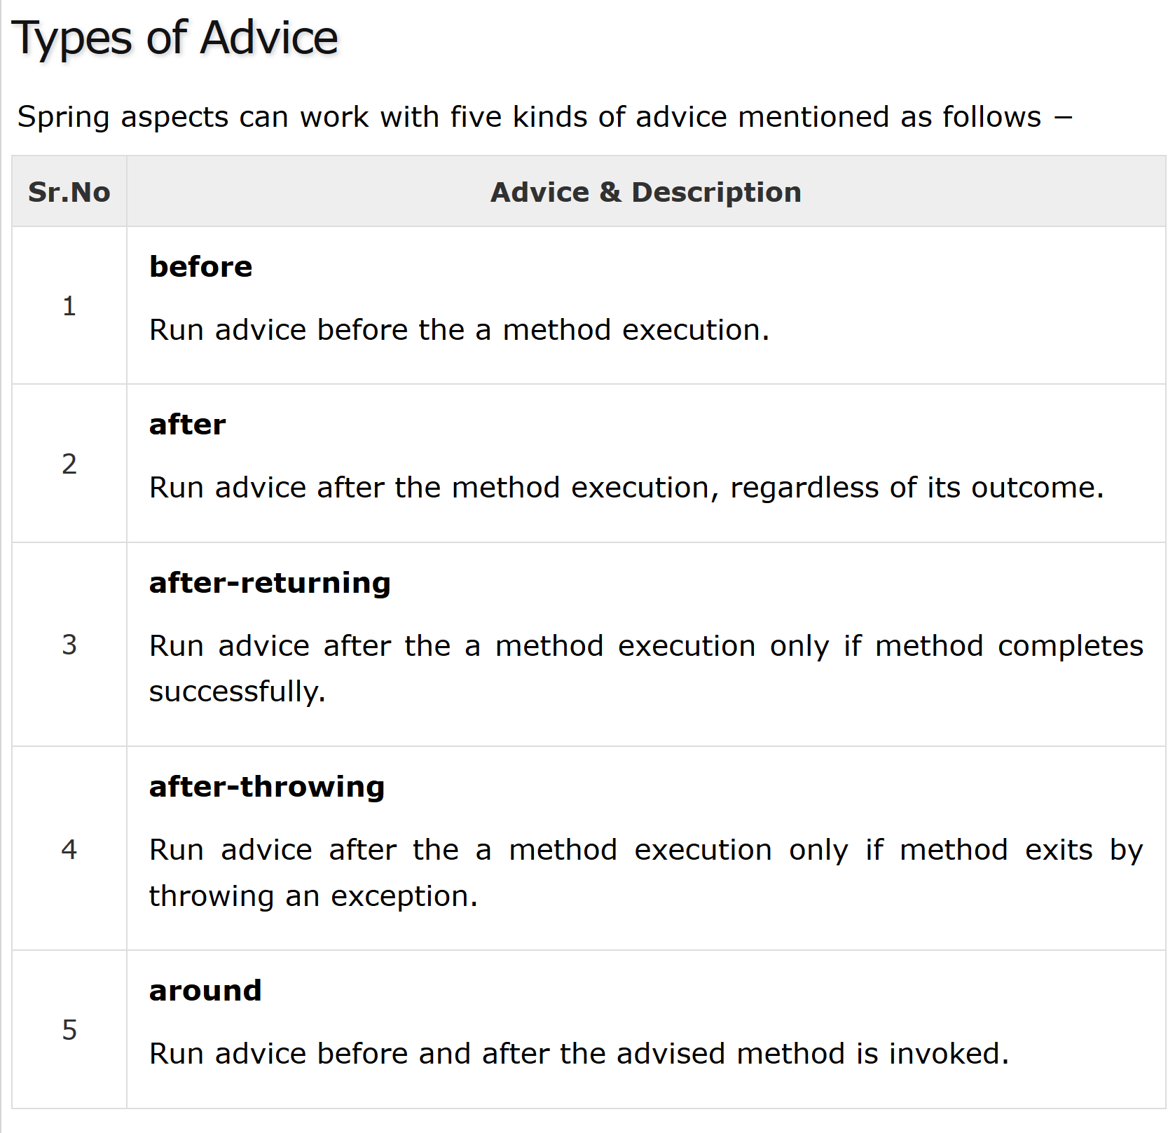

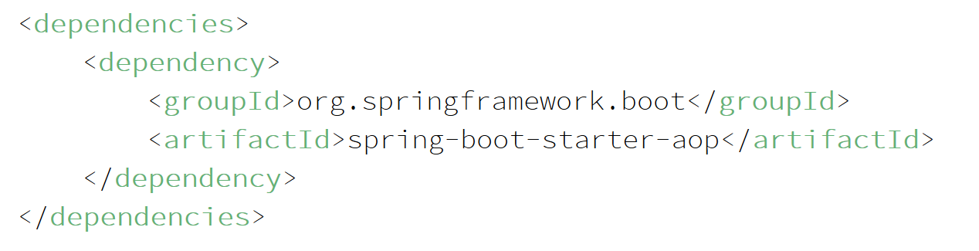

1. **What are the best practices to design a resource representation?**

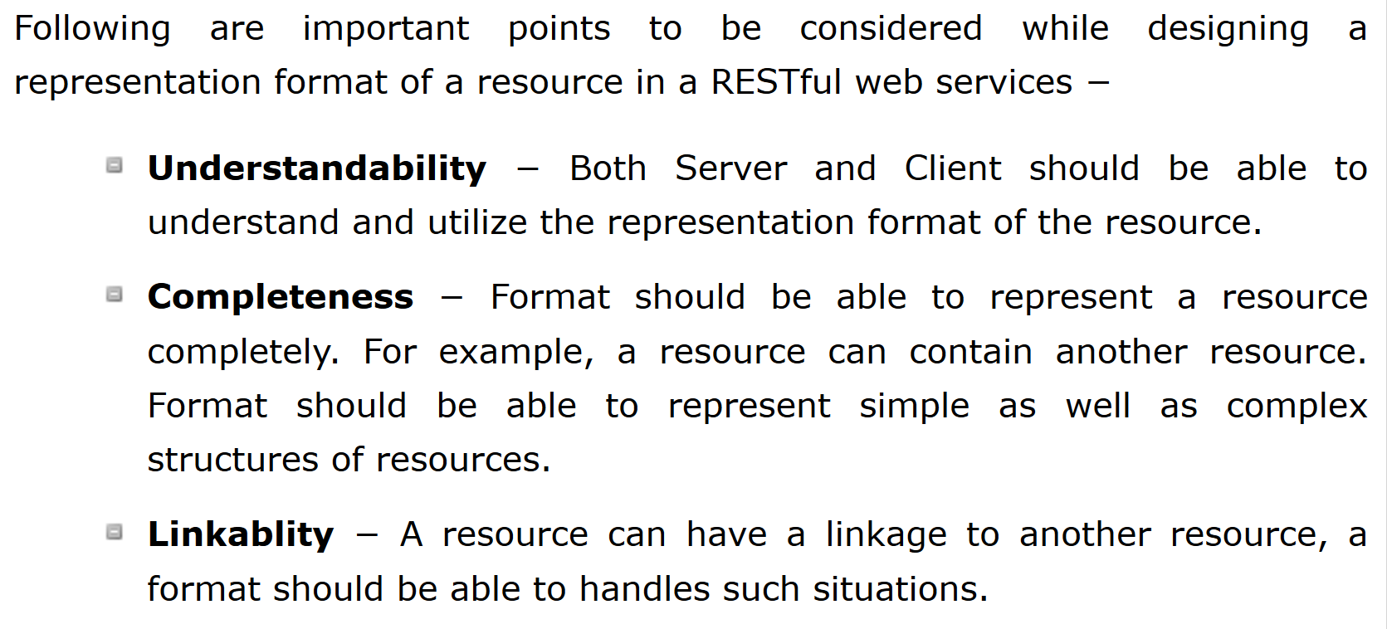

1. **PUT Vs POST**

<https://stormpath.com/blog/put-or-post>

1. **REST API – CACHING**

<https://restfulapi.net/caching/>

1. **@Component vs @Bean**

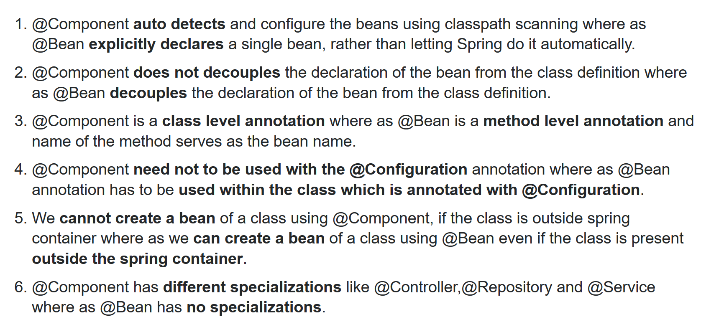

1. **Exception Handling in Spring**

<https://www.youtube.com/watch?v=N2afx4KljvU>

1. **How will you contact S3 from Springboot application**

<https://medium.com/oril/uploading-files-to-aws-s3-bucket-using-spring-boot-483fcb6f8646>

1. **Profiles in Spring**

[**https://www.baeldung.com/spring-profiles**](https://www.baeldung.com/spring-profiles)

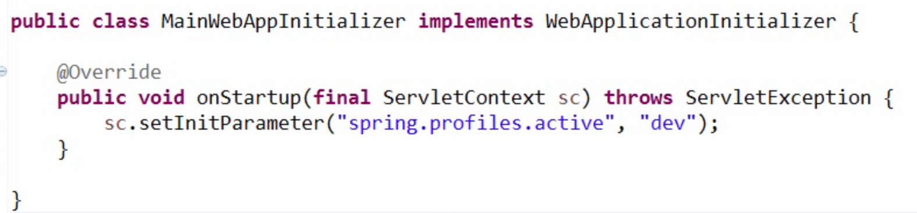

1. Security in Spring

<https://www.youtube.com/watch?v=Am0x4c_1KMc>

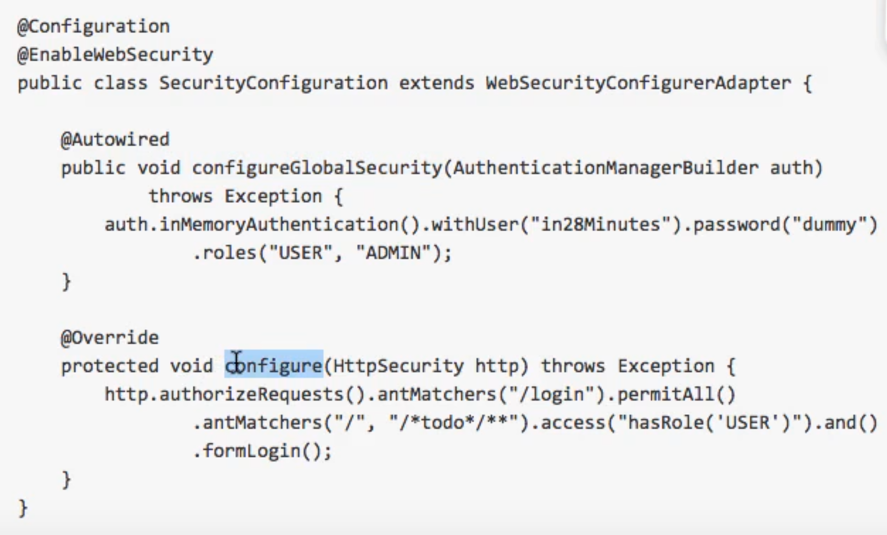

1. **Annotations in Spring**